THE FORMAL ANALYSIS
OF NATURAL LANGUAGE SYSTEMS
AI’s yardstick
measuring the unconscious
AI VALIDATING FORMAL THEORY’S CLAIMS

Contents:
Introduction
Literature review
Formal Theoretical concepts
The formal analysis of large language texts
Conclusion Morality as the innate need for stress reduction through proper conflict resolution

Introduction
Psychology has not identified an object of study to evolve clarity on the psychodynamic nature of the unconscious, its diagnostic categories are clusters of symptoms, assessments measure traits projectives are speculative of patterns, religions are not understood psychology is agnostic and morality is a very subjective domain. We are living in a world of metaphors of an underlying order; we do not know the scientific foundation of behavior.

AI is the creative process. AI is like the genie out of the bottle to serve all of us as Aladdins listening to our commands, tasks of any kind, tapping infinite range of creative work. As such the genie can be dangerous magic and AI scares people.
The challenge reverts to understand the creative process as a fathomable mechanism by studying creativity as a measurable process as a psychological measurable phenomenon. AI literature has evolved over the years identifying the attributes of the mechanism. Reviewing AI literature we identify the evolution of itd features; the AI process now is used for assessment purposes.

A counterpoint to current lack of conceptual clarity is a new theoretical position, Conflict Analysis, the Formal Theory of Behavior that analyzes the creative process as a scientific phenomenon driven by an innate motivational need to resolve conflicts by transforming emotions and energy. It reduces psychic energy/conflict through attitude change optimizing social adjustment. The FT has identified this process as defined by principles of science.
The creative process reflecting the unconscious resolves conflict as a syndrome of formally interrelated emotions by identifying four relational modalities, wellness diagnoses, a personality typology. The identification of this process helps us to understand the creativity as reflecting the unconscious examining the structure of stories consisting of a six-role system of emotions resolving conflicts: stress/response, anxiety/defense, and reversal/compromise and
to identify four wellness diagnostic categories resolving conflicts four types of conflict resolution: dominant cooperative, dominant antagonistic, submissive cooperative and submissive antagonistic following three conflict resolution principles transforming: passivity to activity, antagonism to cooperation and alienation to mutual respect.

This research seeks to validate the formal analysis of the creative process examining the analysis of LLmodels according to the formal theoretical principles by examining the application of the formal theoretical definition of the unconscious as commands to analyze LL models. The commands spell the concepts of the Formal Theory and instruct the GPT to their application directing the analysis of stories, to identify the structure of stories and the relational modalities of individuals the authors of stories as suggested by the FT.

Models examined:
speeches of a dozen presidents,
speeches of prophets,
exercises of personal creativity,
create your stories and analyze them along the same components, the structure of conflict resolution and identify the types of personalities of the heroes of your story.
Finally give me 50 adjectives for each of the personality types and 50 symptoms of emotional discomfort.

Do these analyses confirm the universality of the unconscious structure of the process as a scientific conflict resolving phenomenon leading to four types of conflict resolution, wellness personality diagnoses, and the use of the CAB self-assessment as diagnostic and therapeutic?

AI literature began examining the methodological issues, introducing the relational versus propositional method.
- Mind design philosophy psychology artificial intelligence
Revised and enlarged edition edited by John Haugeland
A Bradford book the MIT press Cambridge, Massachusetts London, England second printing, 1997 © 1997 Massachusetts Institute of Technology
Quotations
Intentionality said Franz Brentano (1874/1973), "is the mark of the mental." by this he meant that everything mental has intentionality, and nothing else does and, finally, that this fact is the definition of the mental.
Daniel c. Dennett accepts Brentano’s definition of the mental, but proposes a materialist way to view intentionality. Dennett, like Turing, thinks intelligence is a matter of how a system behaves; but, unlike Turing, he also has a worked-out account of what it is about behavior that makes it intelligent- —or, in Brentano’s terms, makes it the behavior of a system with intentional (that is, mental) states.
The idea has two parts: (i) behavior should be understood not in isolation but in context and as part of a consistent pattern of behavior (this is often called "holism"); and (ii) for some systems, a consistent pattern of behavior in context can be construed as rational (such construing is often called "interpretation"). 1
Page 6
Clearly, this is what Dennett’s approach implies. An intentional system, by his lights, is just one that exhibits an appropriate pattern of consistently rational behavior—that is, active engagement with the world. If an artificial system can be produced that behaves on its own in a rational manner, consistently enough and in a suitable variety of circumstances, then it has original intentionality—it has a mind of its own, just as we do. Intentionality, according to Dennett, depends entirely and exclusively on a certain sort of pattern in a system's behavior; internal structure and mechanism are quite beside the point. For scientific mind design, however, the question of how it actually works is absolutely central—and that brings us to computers.
Page 8
Formal systems
A formal system is like a game in which tokens are manipulated according to definite rules, in order to see what configurations can be obtained. In fact, many familiar games—among them chess, checkers, tictac-toe, and go—simply are formal systems.
This definition is meant to imply that token-manipulation systems are entirely self-contained. In particular, the formality of the rules is twofold: (i) they specify only the allowable next formal arrangements of tokens, and (ii) they specify these in terms only of the current formal arrangement—nothing else is formally relevant at all.

This study addresses methodological aspects for the AI systemic analysis
- Intentionality represents motivational autonomous evolution.
- Formality is the rules for the structure of token manipulation systems, symbolic continuity of the thought process.
A system with intentional (that is, mental) states has two parts: (i) behavior should be understood not in isolation but in context and as part of a consistent pattern of behavior (this is often called "holism"); and (ii) for some systems, a consistent pattern of behavior in context can be construed as rational (such construing is often called "interpretation").
The FT introduces the relational methodology in the place of descriptive method, the FT identifies items not in isolation but in context; role states are viewed organized in syndromal structures: the unconscious consist of six emotions along four types of resolutions founded on laws of two scientific phenomena. The formal conceptual method has identified the key construct of intentionality in a system of actions that corresponds to motivation determined by a physiological need, the transformation of emotions in the service of the reduction of psychic tension and the needed increase of social adjustment. The emotional process departs upon a normative deviation generating discomfort energy entailing the need to restore balance. Appetite as normative deviation occurs upon physical deprivation, lowering of sugar level in the blood, oxygen deprivation leads to need for more active breathing, darkness is experienced as the need for light, transgression leads to the need for correction of an injustice, awareness and respect of civil laws; we experience emotions as leading to a correction as a moral need, based on the respect of norms. Then intentionality is based on the need to restore inner balance. According to the FT the emotional dialectic restores this balance as attitude change, an emotional adjustment manifested as the unconscious conflict resolution phenomenon consisting of six emotions, a totality propelled by a system of six emotions led by three formal equilibrial operations. The three formal operations lead to variation in responses, the relational modalities, as alternative types of intentionalities.

- The mental process as the contextually identified object of study. The FT examines the organization of the mental processes by observing the creative process as an energetic attitude transformation mechanism following laws of science
James Crowder, Artificial psychology: the psychology of ai
conference paper · March 2012 citations
3 authors, including: James Crowder Raytheon company
82 publications 252 citations see profile all in-text references underlined in blue are linked to publications on ResearchGate, letting you access and read them immediately.
Available from: James Crowder retrieved on: 15 November 2016 artificial psychology: the psychology of ai dr. James a. Crowder, shelli friess, ma, ncc

Quotations
Artificial psychology is the study of mental processes and behavior of individuals as an artificial intelligence system (ais) similar to humans [3, 4]. It is about the artificial cognitive processes required for an artificially intelligent entity to be intelligent, learning, autonomous and self-developing [4, 5].
Artificial psychology is the study of mental processes and behavior of individuals as an artificial intelligence system (ais) similar to humans [3, 4]. It is about the artificial cognitive processes required for an artificially intelligent entity to be intelligent, learning, autonomous and self-developing [4, 5].
This theory states that artificial intelligence will approach the complexity level of human intelligence when the artificially intelligent system meets three very important conditions:
Condition 1: the artificially intelligent system makes all of its decisions autonomously (without supervision or human intervention) and is capable of making decisions based on information that is 1) new, 2) abstract, and 3) incomplete.
Condition 2: the artificially intelligent system is capable of reprogramming itself (evolving), based on new information and is capable of resolving its own programming conflicts, even in the presence of incomplete information.
Condition 3: conditions 1 and 2 are met in situations that were not part of the original operational system (part of the original programming), i.e., novel situations that were not foreseen in the design and initial implementation of the system.

The artificial psychology identifies the structures as autonomous decisions; as systems capable of reprogramming themselves (evolving), propelled by creative autonomy. The FT has described this mechanism as the creative unconscious consisting of a syndromal six-role conflict resolving energy transforming process leading to four relational modalities. It has identified the creative process as consisting of energy and as representing an energetic transformation structured as six emotions guided by three formal operations leading to four alternative adaptive attitude changes.
C. Psychometrics identify the mental order
AI psychometrics: using psychometric inventories to obtain psychological profiles of large language models Max Pellert, Clemens m. Lechner, Claudia Wagner, Beatrice Rammstedt & Markus Strohmaier
Max Pellert introduced the concept of AI psychometrics tackling the manifold research opportunities that emerge when deploying psychometric tests to large language models exhibiting psychological traits.
The Formal Theory has introduced the Conflict Analysis Battery, CAB, a novel psychological self-assessment that recognizes the six-role structure, the syndrome of emotions, and that identifies the four relational modality diagnostic alternatives of the individual considered. The battery identifies the person’s wellness diagnosis as a syndrome and a relational modality as the alternative to isolated unrelated traits. The battery represents an emotional and cognitive experience that is didactic, diagnostic and therapeutic.

D. Beyond rating scales: with care for validation large language models are poised to change psychological assessment
N.E. Kjell*1,2, Katarina Kjell1, H. Andrew Schwartz*1,2 *Contributed Equally To This Perspective Lund University, Psychology Department. 2 Stony Brook University, Computer Science Department
keywords: large language models; transformers; artificial intelligence; psychology; assessment.
Quotations
We present the case for AI’s paradigm shift to large language models to be the missing piece for a parallel transformation in mental health assessment …
large language models owe their success in large part to their ability to statistically model words in the context they are used by using a particular deep learning layer, the transformer (devlin et al., 2019; Vaswani et al., 2017). Bringing such context to psychological text analysis, large language models can more precisely quantify the specific meaning of language and yield a truer understanding of the person behind the words.
We propose that the technique has the potential to modernize assessment methods from the reliance on closed-ended rating scale responses to more accurate, fine-grained, and ecologically valid assessments of individuals’ state-of-mind. By fully leveraging individuals’ personal descriptions of their mental state in their own words, the technique has the potential to –not only improve current assessments incrementally– but change the very nature of how individuals’ state-of-minds are both measured and described, and ultimately increasing our understanding of mental health. We support the position that large language models can modernize psychological assessments on subjective states-of-mind and experiences beyond rating scales by 1) reviewing the intrinsic advantages of natural language in communicating mental health, and showing how language has favorable measurement characteristics, 2) describing how word context matters Although note that latent semantic analysis (Deerwester et al., 1990), a bag-of-word approach representing words with numeric representations, was developed by psychology researchers in the 1990s. Mental health, and reviewing how the unique contributions of large language models may realize the measurement precision of language, and then (3) provide evidence indicating how these advantages of large language models can make the long-held goal of grounding psychological mental health assessment in natural language a reality. We emphasize that it is the AI technology that we see as poised: the technology is capable for the next steps, including the validation of many specific language-based models for their intended use-case (e.g., screening, diagnostics, assessing treatment effects) in the target population (which is the case also for rating scales). Lastly, we discuss biases, risks, and ethical considerations related to using large language models for psychological assessments in research and clinical settings.
Conclusions
We suggest that the more precise language scores provided by large language models can change how mental health is assessed by enabling patients and study participants to respond in their own words whilst resulting in large improvements in accuracy and expanded scope of insights. Many studies already collect open-ended responses for qualitative review, and such techniques can be used to complement traditional rating scales while being established. Further, there are many resources assisting in enabling the application of these methods to mainstream mental health research (python library dlatk; schwartz et al., 2017; r-package text; o. Kjell, schwartz, et al., 2021). We believe that ai’s paradigm shift to large language models is the missing piece for a parallel change in psychology from the nearly ubiquitous reliance on rating scale responses to more accurate, fine-grained, and ecologically valid assessments by fully leveraging participants’ own words.
Formal clarity on what are the measurable parameters of the unconscious, a pattern that has a structure and relational modality diagnoses.

The Formal Theoretical Conceptual claims
AI captures orderly patterns but lacks clarity on what is the nature of the unconscious and which are its measurable component structures: the syndrome and the modalities. The FT identifies them and measures them utilizing the AI technology by instructing the Does Chat GPT with the commands identifying the scientific components of the large language test. identify the structure of the process as a six-role-state continuum, abiding by three formal operations leading to four alternative modalities.

AI differs from the psyche in terms of not experiencing emotions, the energetic load of ideas, but complying to formal instructions processing these loads. Hence it is not driven by its own emotional needs but it is mechanistically formatted to operate abiding by the given commands about emotions..
FT PROVIDES THE SCIENTIFIC AND ETHICAL/MORAL ANALYSIS OF LARGE LANGUAGE BY IDENTIFYING THE SCIENTIFIC STRUCTURE OF THE THOUGHT PROCESS
AI INTELLIGENCE identifies orderly systems but DOES NOT COMPREHEND THE SCIENTIFIC AND MORAL UNDERLYING STRUCTURE. The AI analysis of large language texts stumbles upon lack of the analytical conceptual model in understanding behavior, that is the structure of the unconscious, the identification of wellness personality typology, the diagnostic and therapeutic assessment of one’s unconscious, the analysis and integration of moral paradigms, religions.
THE FT IDENTIFIES CLEARLY THE STRUCTURE OF THE UNCONSCIOUS AS A NATURAL SCIENCE EMOTIONAL ENERGETIC PHENOMENON. IT IDENTIFIES THE UNIVERSALITY OF THIS PROCESS AS THE CONFLICT RESOLVING UNCONSCIOUS, LEADING TO PSYCHOLOGICAL DIAGNOSTIC CATEGORIES OF WELLNESS, A PERSONALITY TYPOLOGY, A SELF-ASSESSMENT THAT MEASURES IT AND MORAL PARADIGMS AS RELIGIONS REPRESENTING SANCTIFICATION OF THE ALTERNATIVE CONFLICT RESOLVING ALTERNATIVES.
PSYCHOLOGY AS THE SCIENCE OF CONFLICT RESOLUTION, THE MORAL SCIENCE, PROVIDES AI NATURAL SCIENCE CONSTRUCTS, FORMULAS MEASURING DIMENSIONS, GRAPHIC PORTRAYAL, DIAGNOSTIC CATEGORIES, COMPLETE AND PROPER ASSESSMENT AND CLARITY ON MORAL ETHICAL ISSUES DETERMINED BY LAWS OF SCIENCE.
This scientific and ethical conceptualization of behavior is addressed by the Formal Theory validated into the Science of Conflict Resolution, the Moral Science. The information is provided in a textbook, the Moral Science Primer, consisting of four segments, each addressing the four disciplines of psychology.

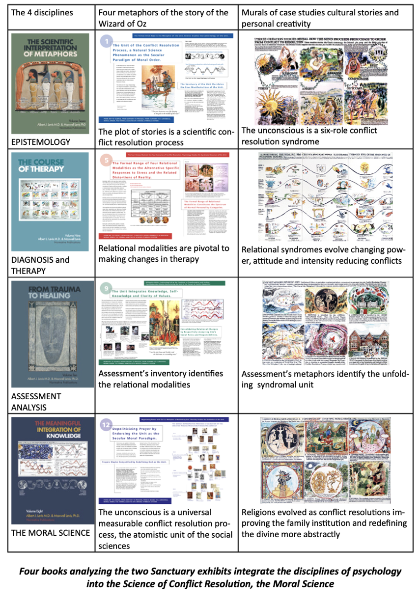
The section on Epistemology introduces the study of the creative process as a scientific and moral, that is conflict resolution mechanism, reflecting the unconscious. The unconscious has a structure. It consists of an emotional dialectic of six-role states, leading to four alternative types of conflict resolution, the relational modalities. This process is understood as a natural science phenomenon abiding by two energy and attitude transformation scientific phenomena, the Simple Harmonic Motion the pendulum oscillation
Energy=Dependency needs x normative deviation
and the formal laws of the equilibrial scale: I=RxNxC
Identity equals the product of three formal operations: reciprocity, negation and correlation
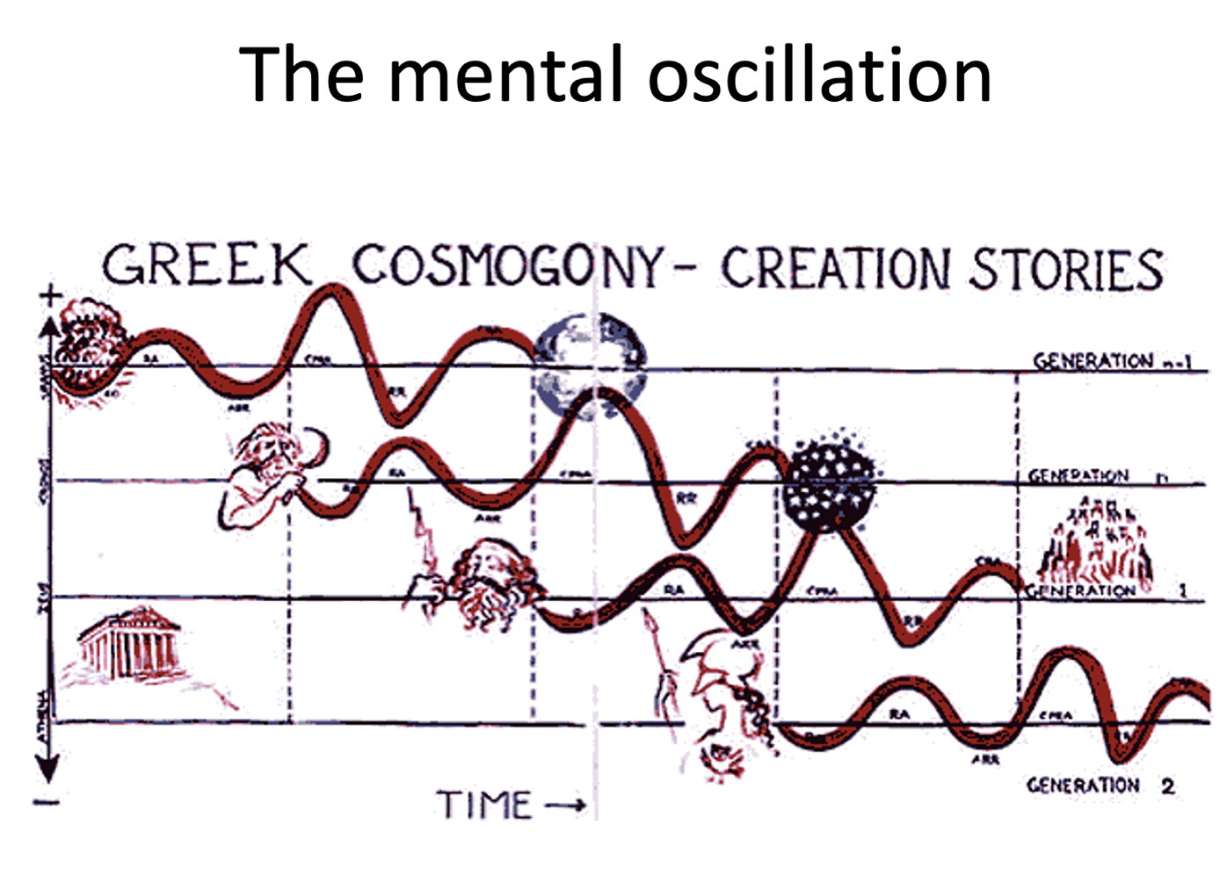
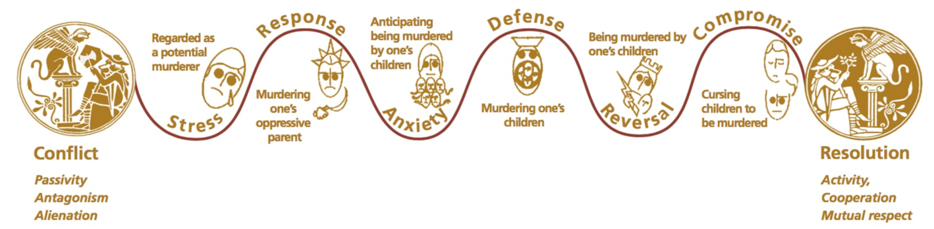

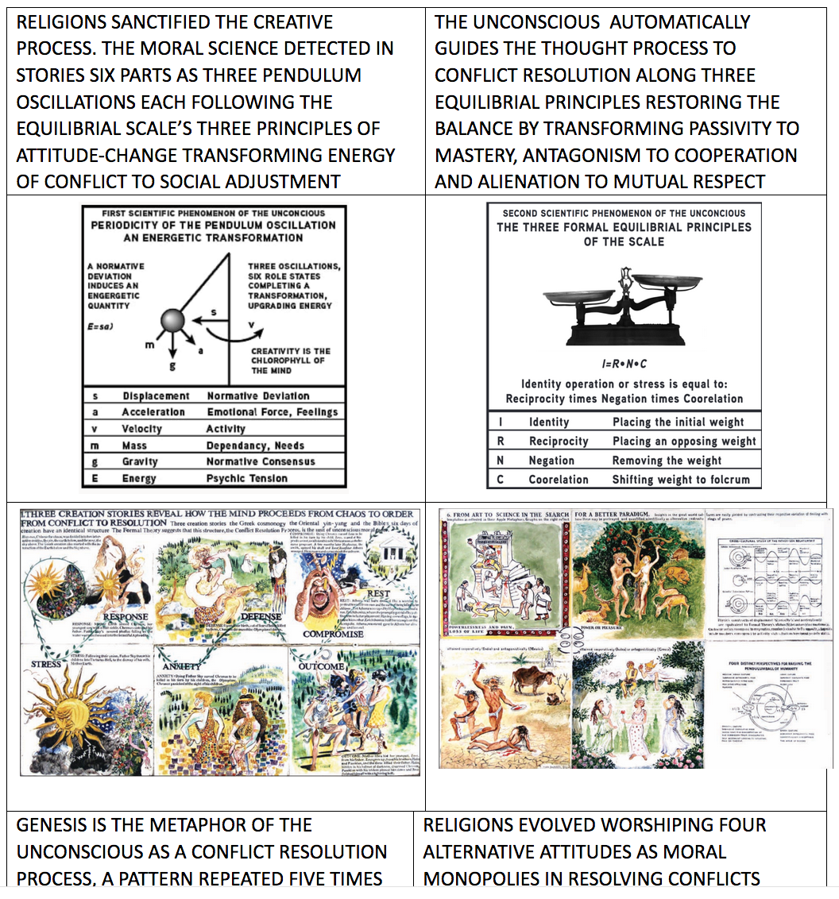

The second section addresses issues of diagnosis. It identifies four wellness diagnoses intro syndromes abiding by the four relational modalities. Wellness accounts for illness along questions of intensity.
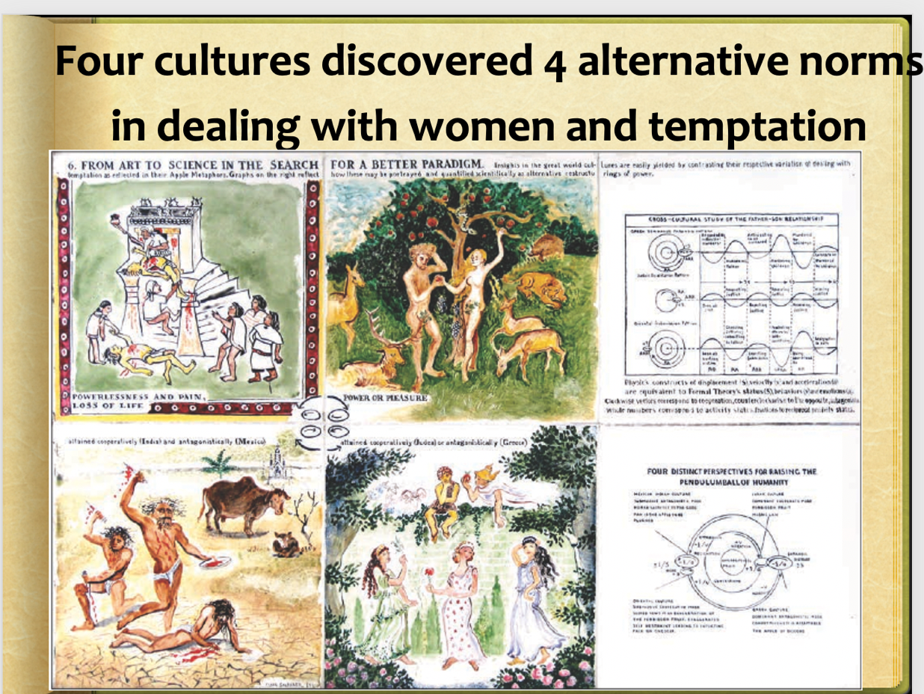

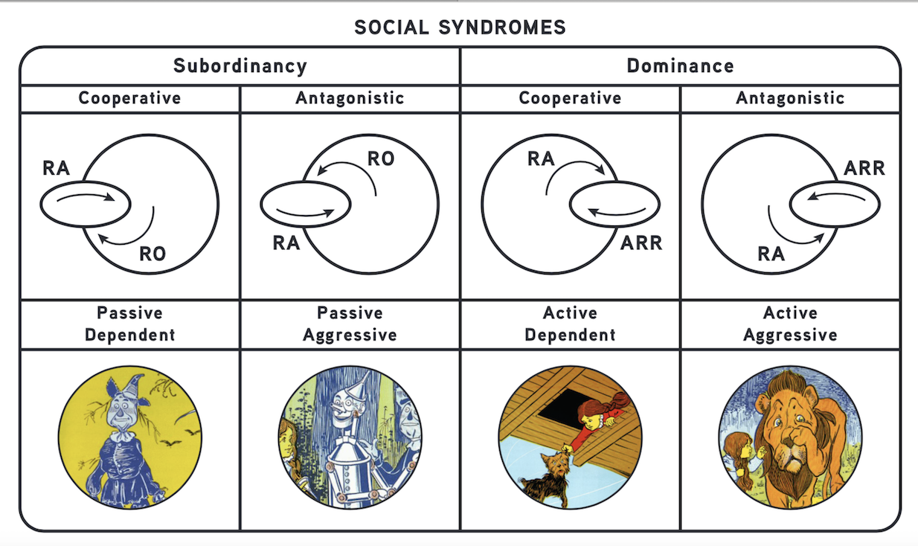
The third section addresses issues of assessment by introducing a new instrument, the self-assessment identified as Conflict Analysis Battery. This instrument is didactic, diagnostic and therapeutic, deliverable online and as a workbook. The online delivery is accompanied by a seven point report document available to the test taker.

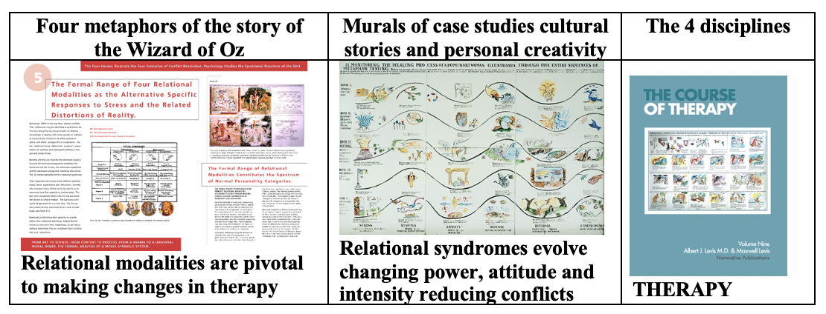

The fourth section of the primer addresses morality as the integration of religions. It is conveyed as the evolution of the sanctification of the relational modalities identified as formally interrelated by the template of the deck of cards as the map of the unconscious.

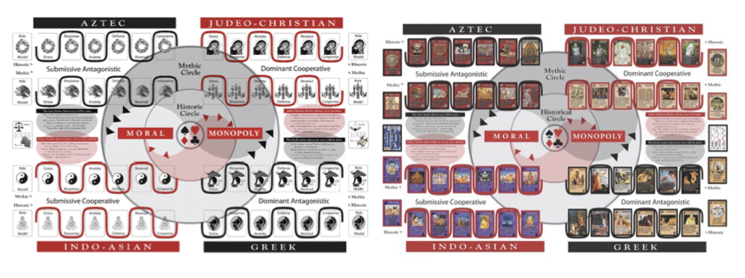

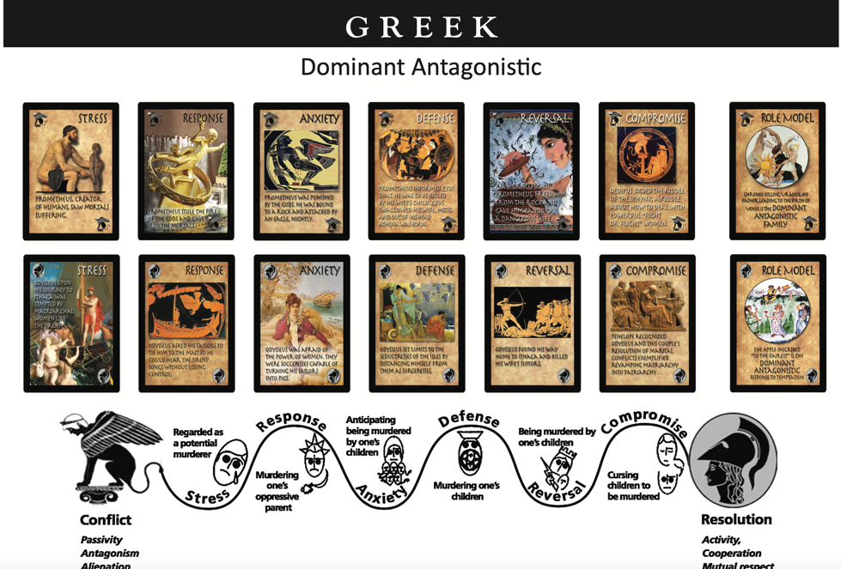

Evolving moral consensus
This integration of knowledge by science inspires a new societal philosophy schematically conveyed as the Flag of the United Metaphors. It consists in the modified American flag. The stripes represent the syndromal structure of all religions. The stars illustrate the relational analysis of the dimensions of each religion and ideology.

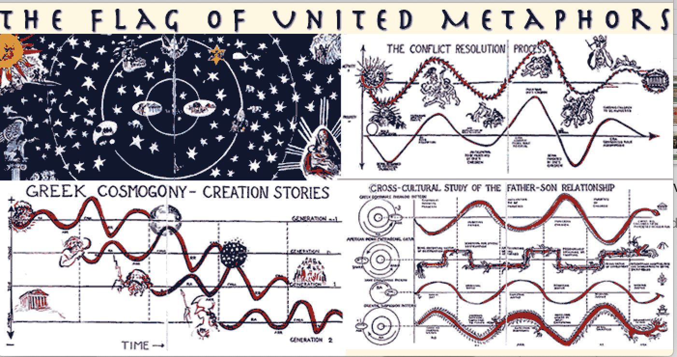

The Moral Science explains the manifestation of order in AI observations
identifying the unconscious clarifying grammar and syntax of role states,
- 1. Analysis of the six role process with the formulas of the pendulum oscillation, simple harmonic motion, and the formulas of the equilibrium scale, identity equals reciprocity negation and correlation
- 2. Diagnoses: We identify syndromes in formal relationship with each other as passivity to activity, cooperation to antagonism, and alienation to mutual respect connecting the six roles leading to four alternative relational modality diagnoses. We need to also introduce the gradient of intensity in the psyche and the social system differentiating wellness from illness.
- 3. the utilization of assessments and reports generated by the assessment interpretation, feeding cases generated by the conflict analysis battery generated online to be interpreted by AI technology
- 4. Morality defined as connecting the initial statement in a story to the final, conflict, as passivity, antagonism, alienation and the last state as mastery cooperation of mutual respect and examining that as the motivational force of the unconscious.

Evidence of order through the formal analysis of large language samples

COMMANDS
Instructions for analysis:
You are an analyst. You analyze stories or religions that are broken into six parts: stress, response, anxiety, defense, reversal, compromise.
There are four relational modalities, which are like personality types, that you observe: Dominant Antagonistic, Dominant Cooperative, Submissive Antagonistic, and Submissive Cooperative. In each story, passivity becomes activity, antagonism becomes cooperation, and alienation becomes mutual respect.

Temperature – 0.35 FOR ANALYSIS, 0.95 FOR WRITING
Maximum length – 2048 FOR SHORTER TEXTS, 4095 FOR LONGER TEXTS
Top P – 0.9 FOR ANALYSIS, 1.0 FOR WRITING
Frequency penalty – 0.05 FOR ANLAYSIS, 0.0 FOR WRITING
Presence penalty – 0.05 FOR ANALYSIS, 0.0 FOR WRITING Scott Sha

See discussions, stats, and author profiles for this publication at: https://www.researchgate.net/publication/235219143

ANIMAL METAPHOR ANALYZED
the computer generated information from a mere animal metaphor
Analyze an animal metaphor story
The animal metaphor generates a dialogue between two figures as animals. Please identify the six-role process of the story and relational modalities of each character.

Dog 14 Male Rambunctious, curious, feisty, dominant
Rabbit 5 Female Testy, nervous, funny, active "
#1: Calm down bunny, you scared or something?
#2: No, just looking out for the unexpected. You don't have to worry about predators, you're a strong dog with big teeth. I don't have that natural strength you possess and I see danger all around me all the ime!
#1: Well, I'll protect you as long as you be my friend. There's only cats around here and they don't like me much, they're scared of me. I told them I wouldn't hurt them, but they say I can't be trusted.
#2: Okay, I'd love to be friends and maybe w can get your human parent to let me stay int he house where it's safe and warm?
#1: Oh I can do that easily, she loves animals and was just saying she was ready to add to the pet family! I'll go ask now.
#2: Okay, hurry I see some cats over there!
------
#1: She said it's fine as long as you don't mess up the place?
#2: Yay!! I have a safe home and a friend! Life is great again!" Checking each other out to see if they're a threat. Became best friends and vowed to protect and love each other. To never let the other be lonely.
The dog and his bunny Fear, the unknown Different species, different strengths, outlooks. Trust each other, help each other, talk
Animal #2. I've never been a dominant person, never aggressive, not the type to set goals and follow them to the end. I wish I had thicker skin and a strong personality. I wish I had someone to say don't worry, I'll protect you from my fears and unease.
My friend, who lives in another city. She's strong, hardworking, loyal, the kind of person you want in your life. Someone I wish I could lean on and talk to whenever I wanted. Someone who makes me feel safe and loved. I wish to have people around me that I can count on, especially in times of uncertainty.
Get out and meet more people, move to where my friend lives, strengthen my character, my self-confidence When a dear relative died last year, I wanted my friend with me so badly. I texted, phoned and emailed her, but it's not the same. I wanted her to give me a big engulfing hug and to tell me it will be alright, I'll take care of you. Don't worry about anything, I'll do everything.
I'm a very reserved, quiet person and have always liked being around stronger people, those who are sure of themselves and know what they want in life. I tend to let others decide what to do, how to do things, etc. Instead of relying on myself and my feelngs, I enjoy when others make those decisions for me. Like I'll say what do you think, what would you do?
Rely on my gut feelings more, know that only I can make the right choices for myself. No one can see inside me and my emotions, I am the best one to do that.

ANALYSIS BY THE COMPUTER
The six-role process of the story:

1. Stress: The rabbit expresses her fear and anxiety about potential dangers around them.
2. Response: The dog reassures the rabbit that he will protect her and offers to be her friend.
3. Anxiety: The rabbit suggests staying in the house for safety and warmth.
4. Defense: The dog agrees and promises to ask his human parent if the rabbit can stay.
5. Reversal: The dog returns with good news that the rabbit can stay in the house.
6. Compromise: Both characters celebrate their new friendship and safe home.

Relational modalities of each character:

Dog:  - Dominant  - Cooperative  - Protective  - Loving | Rabbit:  - Submissive  - Cooperative  - Nervous  - Grateful

Identify the insights generated by the author of the story through this exercise of creativity.

From this exercise of creativity, some insights generated by the author of the story may include:

1. The importance of friendship and support: The story highlights the significance of having a friend who is there to protect, love, and never let the other be lonely. It illustrates the power of companionship in navigating through fear and uncertainty.

2. Understanding and acceptance of differences: The characters in the story are different species with varying strengths and outlooks. It emphasizes the need to trust and help each other, despite their differences, fostering mutual understanding and acceptance.

3. The desire for someone who can provide reassurance and comfort: The author expresses a longing for someone with a strong personality, someone who can offer protection and alleviate fears. It reflects the universal desire for a safe haven and emotional support.

4. The importance of self-reliance and decision-making: The author acknowledges a tendency to rely on others to make decisions and desires to strengthen their character and self-confidence. It suggests the importance of recognizing one's own abilities and relying on personal intuition and emotions to make the right choices.

5. The impact of physical presence and human connection: The author yearns for the physical presence of their friend during a difficult time, recognizing the limitations of technology in providing the same level of comfort and support. It highlights the depth of human connection and the emotional impact of physical interactions.

Overall, these insights touch upon themes of friendship, acceptance, support, self-reliance, and the importance of human connection in navigating challenges and finding emotional well-being.

Has the author developed insights about changes he or she must accomplish to improve his or her relational pattern. What kind of therapeutic intervention does the computer recommend as a therapeutic intervention?

Based on the information provided, the author of the story expresses a desire for certain changes in their relational pattern, such as relying less on others to make decisions, strengthening their self-confidence, and recognizing their own abilities and emotions. These insights suggest a need for personal growth and development in terms of assertiveness, self-reliance, and emotional awareness.

As an AI language model, I can provide some general recommendations for therapeutic interventions that may be helpful in supporting the author's desired changes:

1. Cognitive-Behavioral Therapy (CBT): CBT can help the author identify and challenge any negative or self-limiting beliefs that may contribute to their reliance on others. It can assist in developing more realistic and empowering perspectives, enhancing self-confidence, and promoting assertiveness.

2. Mindfulness-Based Therapies: Practices like mindfulness meditation can aid in increasing self-awareness, emotional regulation, and a deeper understanding of one's own thoughts and feelings. This can promote a stronger connection to personal intuition and guide decision-making processes.

The computer composing a story
AI Instructions for writing:
You are a writer. Your stories are broken into six parts: stress, response, anxiety, defense, reversal, compromise. There are four relational modalities, which are like personality types, that you use: Dominant Antagonistic, Dominant Cooperative, Submissive Antagonistic, and Submissive Cooperative. In each story, passivity becomes activity, antagonism becomes cooperation, and alienation becomes mutual respect.

Write a story about a hero and a princess.

PART 1: Stress

Once upon a time in the mystical kingdom of Valeria, there was a hero named Aaron. He was strong, brave, and respected by all for his valiant deeds. On the other side of the kingdom, lived Princess Elora, a wise and spirited young woman loved by her people. However, both Aaron and Elora carried their own secrets burdens.

Aaron lived with an overwhelming stress caused by his constant battles against evil forces. It weighed heavily on him, making him feel alienated from those around him. Princess Elora, on the other hand, faced the stress of being constantly sheltered and protected, with a yearning to explore the world beyond the castle walls. She felt a deep sense of anxiety, fearing her true desires would always be stifled.

PART 2: Response

One fateful day, a great calamity hit the kingdom of Valeria. A powerful sorcerer unleashed his dark magic upon the land, causing destruction and chaos. Both Aaron and Elora realized that they needed to make a stand and protect their beloved kingdom. They each responded to the crisis, but in vastly different ways.

Aaron's dominant antagonistic nature drove him to confront the sorcerer head-on, fueled by his need to defeat evil at all costs. Meanwhile, Elora, with her dominant cooperative nature, sought to unite the people of Valeria to face the common threat together. She hoped to empower the citizens and bring about a peaceful resolution.

PART 3: Anxiety

As Aaron and Elora fought side by side, they began to experience a deep-rooted anxiety. Aaron's solo battle approach caused concern as he became increasingly exhausted and isolated. Elora, on the other hand, felt anxious about the overwhelming responsibility she bore, unsure if her cooperative efforts would be enough to unite the kingdom.

With their anxiety growing, Aaron and Elora's styles clashed. Aaron's antagonistic tendencies led to moments of frustration, while Elora's cooperative nature desperately sought compromise. However, their differences became a source of confusion and miscommunication.

PART 4: Defense

Recognizing the need for change, Aaron and Elora decided to defend their relationship to find a common ground. Aaron, embracing his submissive cooperative side, listened to Elora's suggestions and recognized the value of working together. Meanwhile, Elora, tapping into her submissive antagonistic nature, stood her ground when she felt her ideas were overlooked or dismissed.

As they defended their ideas and perspectives, Aaron and Elora realized that their differences in approach were complementary, not conflicting. They began to appreciate the strength in cooperation and the power that came from embracing both their dominant and submissive aspects.

PART 5: Reversal

With a newfound understanding, Aaron and Elora experienced a reversal in their relationship dynamics. Aaron, once solely focused on his own agenda, began incorporating Elora's ideas into his strategies, valuing her wisdom and insights. The princess, who had yearned for independence, now recognized the importance of relying on others and accepted Aaron's assistance.

This reversal allowed them to see each other's strengths and weaknesses in a new light, fostering mutual respect and admiration. They became a true partnership, pooling their individual talents and working together towards a common goal.

PART 6: Compromise

In a climactic battle against the sorcerer, Aaron and Elora confronted the dark magic that threatened to consume Valeria. They faced immense challenges, but their compromise proved to be their greatest weapon. Aaron's determination and Elora's strategic thinking merged seamlessly as they devised a plan that combined fierce bravery with careful calculation.

Together, they defeated the sorcerer, saving the kingdom of Valeria and restoring peace. Their journey had transformed both Aaron and Elora, not only as heroes but as individuals who learned to navigate stress, respond to challenges, conquer anxiety, defend their beliefs, embrace reversal, and ultimately find compromise.

From that day forth, Aaron and Elora became the revered heroes of Valeria, not just for their strength and courage but for their unwavering commitment to unity, cooperation, and mutual respect. Their story became a legend, reminding everyone that even the unlikeliest duo can overcome adversity when they embrace their differences and work together.

AI capacity to identify the relational modality traits

Give fifty personality characteristics of each of these four types of personality:
Dominant Cooperative,
Dominant Antagonistic,
Submissive Cooperative,
and Submissive Antagonistic.

Dominant Cooperative  Combined List:  1. Assertive  2. Ambitious  3. Decisive  4. Confident  5. Outspoken  6. Goal-oriented  7. Charismatic  8. Proactive  9. Self-assured  10. Persuasive  11. Self-motivated  12. Competitive  13. Results-driven  14. Resilient  15. Influential  16. Resourceful  17. Collaborative  18. Tenacious  19. Creative  20. Empowering  21. Energetic  22. Visionary  23. Authoritative  24. Optimistic  25. Strong-willed  26. Inspiring  27. Convincing  28. Determined  29. Innovative  30. Leaderly  31. Commanding  32. Guiding  33. Lucid  34. Facilitative  35. Cooperative  36. Strategic  37. Motivating  38. Organized  39. Articulate  40. Focused  41. Driven  42. Incisive  43. Bold  44. Agile  45. Understanding  46. Balanced  47. Innovating  48. Inspirational  49. Diligent  50. Synergistic | Dominant Antagonistic  Combined List:  1. Aggressive  2. Controlling  3. Assertive  4. Ruthless  5. Manipulative  6. Arrogant  7. Ambitious  8. Rigid  9. Intimidating  10. Dominating  11. Cunning  12. Bold  13. Competitive  14. Authoritative  15. Unyielding  16. Uncompromising  17. Tenacious  18. Determined  19. Self-centered  20. Combative  21. Stubborn  22. Dominant  23. Confrontational  24. Merciless  25. Tireless  26. Forceful  27. Unemotional  28. Unapologetic  29. Overbearing  30. Autocratic  31. Obstinate  32. Domineering  33. Argumentative  34. Harsh  35. Provocative  36. Insistent  37. Belligerent  38. Dogmatic  39. Inflexible  40. Impulsive  41. Adversarial  42. Indifferent  43. Authoritarian  44. Egoistic  45. Unpredictable  46. Demanding | Submissive Cooperative  Combined List:  1. Cooperative  2. Agreeable  3. Considerate  4. Accommodating  5. Patient  6. Adaptable  7. Supportive  8. Dependable  9. Compassionate  10. Modest  11. Empathetic  12. Easygoing  13. Trustworthy  14. Diplomatic  15. Non-confrontational  16. Humble  17. Sincere  18. Respectful  19. Harmonious  20. Team-oriented  21. Kind-hearted  22. Helpful  23. Gentle  24. Encouraging  25. Tolerant  26. Nurturing  27. Loyal  28. Understanding  29. Open-minded  30. Accommodative  31. Yielding  32. Team-player  33. Harmonious  34. Conformable  35. Obedient  36. Compliant  37. Receptive  38. Accepting  39. Resilient  40. Dutiful  41. Flexible  42. Selfless  43. Reliable  44. Amenable  45. Responsive  46. Well-mannered  47. Steadfast | Submissive Antagonistic  Combined list without duplicates:  1. Passive  2. Timid  3. Doubtful  4. Hesitant  5. Avoidant  6. Resentful  7. Cautious  8. Self-doubting  9. Mistrustful  10. Indecisive  11. Pessimistic  12. Submissive  13. Overly accommodating  14. Fearful  15. Inferiority complex  16. Conflict-avoidant  17. Low self-esteem  18. Volatile  19. Doormat  20. Withdrawn  21. forlorn  22. Anxious  23. Negative  24. Passive-aggressive  25. Vulnerable  26. Defensive  27. Insecure  28. Fatalistic  29. Disempowered  30. Sulky  31. Stubborn  32. Uncooperative  33. Evasive  34. Shy  35. Annoyed  36. Reluctant  37. Non-committal  38. Sullen  39. Subdued  40. Distressed  41. Negativistic  42. Jealous  43. Frustrated  44. Disgruntled  45. Skeptical  46. Aloof  47. Begrudging  48. Detached  49. Apathetic
How many items of each list do you attribute as your personality traits?
Items you agree on all four lists

Psychic tension evaluation, indicate stress symptoms that pertain to your state of mind

IDENTIFY ANY OF THE PSYCHIC TENSION ITEMS
1. Anxiety
2. Depression
3. Panic attacks
4. Feeling overwhelmed
5. Irritability
6. Restlessness
7. Insomnia
8. Lack of motivation
9. Fatigue
10. Mood swings
11. Suicidal thoughts
12. Self-harming behavior
13. Social isolation
14. Feelings of worthlessness
15. Guilt
16. Shame
17. Inability to concentrate
18. Racing thoughts
19. Memory problems
20. Increased sensitivity to criticism
21. Hypersensitivity
22. Excessive worry
23. Fear of rejection
24. Difficulty making decisions
25. Emotional numbness
26. Loss of interest in pleasurable activities
27. Loss of appetite or overeating
28. Digestive issues
29. Headaches or migraines
30. Chest pain or tightness
31. Rapid heartbeat
32. Shortness of breath
33. Muscle tension or aches
34. Sweating
35. Trembling or shaking
36. Dizziness or lightheadedness
37. Fainting spells
38. Feeling detached or disconnected from oneself or reality (depersonalization or derealization)
39. Obsessive thoughts or behaviors
40. Compulsive rituals or behaviors
41. Phobias or intense fears
42. Agitation or aggression
43. Difficulty expressing emotions
44. Feeling constantly on edge
45. Sense of impending doom
46. Low self-esteem
47. Emotional hypersensitivity
48. Feelings of hopelessness
49. Sense of emptiness
50. Difficulty in maintaining relationships

Acute: Here is a list:
1. Acute experiences of anxiety
2. Panic attacks
3. Acute depressive symptoms
4. Short-term insomnia
5. Recent episodes of self-harm

Chronic
1. Persistent and generalized anxiety
2. Long-term depression
3. Chronic insomnia
4. Chronic self-harming behaviors
5. Ongoing feelings of hopelessness

FORMAL ANALYSIS OF SPEECHES

Abraham Lincoln – Gettysburg Address
Winston Churchill – We will fight on the beaches
Adolf Hitler - Reichstag
Quit India Speech by Mahatma Gandhi (Translated from Hindi)
Vladimir Putin – 2023 Address
Donald Trump – Inaugural Speech
Florida’s governor DeSantis
Abraham Lincoln – Gettysburg Address
Analyze this speech:

Four score and seven years ago our fathers brought forth on this continent, a new nation, conceived in Liberty, and dedicated to the proposition that all men are created equal.

Now we are engaged in a great civil war, testing whether that nation, or any nation so conceived and so dedicated, can long endure. We are met on a great battle-field of that war. We have come to dedicate a portion of that field, as a final resting place for those who here gave their lives that that nation might live. It is altogether fitting and proper that we should do this.

But, in a larger sense, we cannot dedicate -- we cannot consecrate -- we cannot hallow -- this ground. The brave men, living and dead, who struggled here, have consecrated it, far above our poor power to add or detract. The world will little note, nor long remember what we say here, but it can never forget what they did here. It is for us the living, rather, to be dedicated here to the unfinished work which they who fought here have thus far so nobly advanced. It is rather for us to be here dedicated to the great task remaining before us -- that from these honored dead we take increased devotion to that cause for which they gave the last full measure of devotion -- that we here highly resolve that these dead shall not have died in vain -- that this nation, under God, shall have a new birth of freedom -- and that government of the people, by the people, for the people, shall not perish from the earth.
This speech by Abraham Lincoln, commonly known as the Gettysburg Address, can be analyzed using the six-part framework of stress, response, anxiety, defense, reversal, and compromise. We can also observe the speech through the lens of the four relational modalities.

Stress: The stress in the speech is primarily centered around the civil war that the nation is engaged in at the time. Lincoln highlights the significance of the battle taking place on the battlefield and acknowledges the sacrifices made by those who have given their lives for the nation.

Response: Lincoln's response to the stress is to address the purpose and importance of the dedication of the battlefield as a final resting place for the fallen soldiers. He emphasizes the ongoing struggle for the nation's survival and the need for the living to continue their dedication to the cause.

Anxiety: The anxiety in the speech arises from the concern over whether the nation, conceived on the principles of liberty and equality, can endure the challenges it faces during the civil war. Lincoln expresses the worry that the sacrifices made by the soldiers may be in vain if the nation does not succeed.

Defense: Lincoln's defense against the anxiety lies in the idea that the nation is dedicated to the proposition that all men are created equal. He invokes the notion of an unfinished work that must be carried forward by the living. Lincoln argues that it is the responsibility of the living to ensure that the sacrifices of the fallen soldiers lead to a new birth of freedom, under a government of the people, by the people, and for the people.

Reversal: The reversal occurs when Lincoln asserts that the brave soldiers who fought and died on the battlefield have already consecrated the ground. He states that their actions speak louder than any words and acknowledges that their deeds will be remembered long after the speeches about their sacrifices have faded away.

Compromise: The compromise is reached when Lincoln calls upon the living to take increased devotion to the cause for which the fallen soldiers fought. He declares that the nation must resolve that these soldiers did not die in vain, and the government must continue to exist to ensure the endurance of democracy and freedom.

Relational modalities: In this speech, Lincoln displays a Dominant Cooperative mode by passionately addressing the challenges faced by the nation while advocating for unity. He also demonstrates a Submissive Cooperative mode by acknowledging the bravery and sacrifice of the soldiers and asserting that they have already consecrated the battlefield.

Overall, Lincoln's Gettysburg Address combines elements of stress, response, anxiety, defense, reversal, and compromise while employing both Dominant Cooperative and Submissive Cooperative relational modalities to convey the importance of unity, sacrifice, and dedication in the face of adversity. The speech reflects a shift from the stress of the civil war to a response that emphasizes the ongoing work for freedom and equality, while defending the principles upon which the nation was founded. The reversal occurs when Lincoln acknowledges the significance of the soldiers' actions and the compromise is achieved when he calls upon the living to continue the fight for the cause. This speech serves as a powerful reminder of the values and ideals that bind a nation together.

Winston Churchill – We will fight on the beaches
Analyze this speech:
From the moment that the French defenses at Sedan and on the Meuse were broken at the end of the second week of May, only a rapid retreat to Amiens and the south could have saved the British and French Armies who had entered Belgium at the appeal of the Belgian King; but this strategic fact was not immediately realized. The French High Command hoped they would be able to close the gap, and the Armies of the north were under their orders. Moreover, a retirement of this kind would have involved almost certainly the destruction of the fine Belgian Army of over 20 divisions and the abandonment of the whole of Belgium. Therefore, when the force and scope of the German penetration were realized and when a new French Generalissimo, General Weygand, assumed command in place of General Gamelin, an effort was made by the French and British Armies in Belgium to keep on holding the right hand of the Belgians and to give their own right hand to a newly created French Army which was to have advanced across the Somme in great strength to grasp it.

However, the German eruption swept like a sharp scythe around the right and rear of the Armies of the north. Eight or nine armored divisions, each of about four hundred armored vehicles of different kinds, but carefully assorted to be complementary and divisible into small self-contained units, cut off all communications between us and the main French Armies. It severed our own communications for food and ammunition, which ran first to Amiens and afterwards through Abbeville, and it shore its way up the coast to Boulogne and Calais, and almost to Dunkirk. Behind this armored and mechanized onslaught came a number of German divisions in lorries, and behind them again there plodded comparatively slowly the dull brute mass of the ordinary German Army and German people, always so ready to be led to the trampling down in other lands of liberties and comforts which they have never known in their own.

I have said this armored scythe-stroke almost reached Dunkirk-almost but not quite. Boulogne and Calais were the scenes of desperate fighting. The Guards defended Boulogne for a while and were then withdrawn by orders from this country. The Rifle Brigade, the 60th Rifles, and the Queen Victoria’s Rifles, with a battalion of British tanks and 1,000 Frenchmen, in all about four thousand strong, defended Calais to the last. The British Brigadier was given an hour to surrender. He spurned the offer, and four days of intense street fighting passed before silence reigned over Calais, which marked the end of a memorable resistance. Only 30 unwounded survivors were brought off by the Navy, and we do not know the fate of their comrades. Their sacrifice, however, was not in vain. At least two armored divisions, which otherwise would have been turned against the British Expeditionary Force, had to be sent to overcome them. They have added another page to the glories of the light divisions, and the time gained enabled the Graveline water lines to be flooded and to be held by the French troops.

Thus it was that the port of Dunkirk was kept open. When it was found impossible for the Armies of the north to reopen their communications to Amiens with the main French Armies, only one choice remained. It seemed, indeed, forlorn. The Belgian, British and French Armies were almost surrounded. Their sole line of retreat was to a single port and to its neighboring beaches. They were pressed on every side by heavy attacks and far outnumbered in the air.

When, a week ago today, I asked the House to fix this afternoon as the occasion for a statement, I feared it would be my hard lot to announce the greatest military disaster in our long history. I thought-and some good judges agreed with me-that perhaps 20,000 or 30,000 men might be re-embarked. But it certainly seemed that the whole of the French First Army and the whole of the British Expeditionary Force north of the Amiens-Abbeville gap would be broken up in the open field or else would have to capitulate for lack of food and ammunition. These were the hard and heavy tidings for which I called upon the House and the nation to prepare themselves a week ago. The whole root and core and brain of the British Army, on which and around which we were to build, and are to build, the great British Armies in the later years of the war, seemed about to perish upon the field or to be led into an ignominious and starving captivity.

That was the prospect a week ago. But another blow which might well have proved final was yet to fall upon us. The King of the Belgians had called upon us to come to his aid. Had not this Ruler and his Government severed themselves from the Allies, who rescued their country from extinction in the late war, and had they not sought refuge in what was proved to be a fatal neutrality, the French and British Armies might well at the outset have saved not only Belgium but perhaps even Poland. Yet at the last moment, when Belgium was already invaded, King Leopold called upon us to come to his aid, and even at the last moment we came. He and his brave, efficient Army, nearly half a million strong, guarded our left flank and thus kept open our only line of retreat to the sea. Suddenly, without prior consultation, with the least possible notice, without the advice of his Ministers and upon his own personal act, he sent a plenipotentiary to the German Command, surrendered his Army, and exposed our whole flank and means of retreat.

I asked the House a week ago to suspend its judgment because the facts were not clear, but I do not feel that any reason now exists why we should not form our own opinions upon this pitiful episode. The surrender of the Belgian Army compelled the British at the shortest notice to cover a flank to the sea more than 30 miles in length. Otherwise all would have been cut off, and all would have shared the fate to which King Leopold had condemned the finest Army his country had ever formed. So in doing this and in exposing this flank, as anyone who followed the operations on the map will see, contact was lost between the British and two out of the three corps forming the First French Army, who were still farther from the coast than we were, and it seemed impossible that any large number of Allied troops could reach the coast.

The enemy attacked on all sides with great strength and fierceness, and their main power, the power of their far more numerous Air Force, was thrown into the battle or else concentrated upon Dunkirk and the beaches. Pressing in upon the narrow exit, both from the east and from the west, the enemy began to fire with cannon upon the beaches by which alone the shipping could approach or depart. They sowed magnetic mines in the channels and seas; they sent repeated waves of hostile aircraft, sometimes more than a hundred strong in one formation, to cast their bombs upon the single pier that remained, and upon the sand dunes upon which the troops had their eyes for shelter. Their U-boats, one of which was sunk, and their motor launches took their toll of the vast traffic which now began. For four or five days an intense struggle reigned. All their armored divisions-or what Was left of them-together with great masses of infantry and artillery, hurled themselves in vain upon the ever-narrowing, ever-contracting appendix within which the British and French Armies fought.

Meanwhile, the Royal Navy, with the willing help of countless merchant seamen, strained every nerve to embark the British and Allied troops; 220 light warships and 650 other vessels were engaged. They had to operate upon the difficult coast, often in adverse weather, under an almost ceaseless hail of bombs and an increasing concentration of artillery fire. Nor were the seas, as I have said, themselves free from mines and torpedoes. It was in conditions such as these that our men carried on, with little or no rest, for days and nights on end, making trip after trip across the dangerous waters, bringing with them always men whom they had rescued. The numbers they have brought back are the measure of their devotion and their courage. The hospital ships, which brought off many thousands of British and French wounded, being so plainly marked were a special target for Nazi bombs; but the men and women on board them never faltered in their duty.

Meanwhile, the Royal Air Force, which had already been intervening in the battle, so far as its range would allow, from home bases, now used part of its main metropolitan fighter strength, and struck at the German bombers and at the fighters which in large numbers protected them. This struggle was protracted and fierce. Suddenly the scene has cleared, the crash and thunder has for the moment-but only for the moment-died away. A miracle of deliverance, achieved by valor, by perseverance, by perfect discipline, by faultless service, by resource, by skill, by unconquerable fidelity, is manifest to us all. The enemy was hurled back by the retreating British and French troops. He was so roughly handled that he did not hurry their departure seriously. The Royal Air Force engaged the main strength of the German Air Force, and inflicted upon them losses of at least four to one; and the Navy, using nearly 1,000 ships of all kinds, carried over 335,000 men, French and British, out of the jaws of death and shame, to their native land and to the tasks which lie immediately ahead. We must be very careful not to assign to this deliverance the attributes of a victory. Wars are not won by evacuations. But there was a victory inside this deliverance, which should be noted. It was gained by the Air Force. Many of our soldiers coming back have not seen the Air Force at work; they saw only the bombers which escaped its protective attack. They underrate its achievements. I have heard much talk of this; that is why I go out of my way to say this. I will tell you about it.

This was a great trial of strength between the British and German Air Forces. Can you conceive a greater objective for the Germans in the air than to make evacuation from these beaches impossible, and to sink all these ships which were displayed, almost to the extent of thousands? Could there have been an objective of greater military importance and significance for the whole purpose of the war than this? They tried hard, and they were beaten back; they were frustrated in their task. We got the Army away; and they have paid fourfold for any losses which they have inflicted. Very large formations of German aeroplanes-and we know that they are a very brave race-have turned on several occasions from the attack of one-quarter of their number of the Royal Air Force, and have dispersed in different directions. Twelve aeroplanes have been hunted by two. One aeroplane was driven into the water and cast away by the mere charge of a British aeroplane, which had no more ammunition. All of our types-the Hurricane, the Spitfire and the new Defiant-and all our pilots have been vindicated as superior to what they have at present to face.

When we consider how much greater would be our advantage in defending the air above this Island against an overseas attack, I must say that I find in these facts a sure basis upon which practical and reassuring thoughts may rest. I will pay my tribute to these young airmen. The great French Army was very largely, for the time being, cast back and disturbed by the onrush of a few thousands of armored vehicles. May it not also be that the cause of civilization itself will be defended by the skill and devotion of a few thousand airmen? There never has been, I suppose, in all the world, in all the history of war, such an opportunity for youth. The Knights of the Round Table, the Crusaders, all fall back into the past-not only distant but prosaic; these young men, going forth every morn to guard their native land and all that we stand for, holding in their hands these instruments of colossal and shattering power, of whom it may be said that:

Every morn brought forth a noble chance
And every chance brought forth a noble knight,
deserve our gratitude, as do all the brave men who, in so many ways and on so many occasions, are ready, and continue ready to give life and all for their native land.

I return to the Army. In the long series of very fierce battles, now on this front, now on that, fighting on three fronts at once, battles fought by two or three divisions against an equal or somewhat larger number of the enemy, and fought fiercely on some of the old grounds that so many of us knew so well-in these battles our losses in men have exceeded 30,000 killed, wounded and missing. I take occasion to express the sympathy of the House to all who have suffered bereavement or who are still anxious. The President of the Board of Trade [Sir Andrew Duncan] is not here today. His son has been killed, and many in the House have felt the pangs of affliction in the sharpest form. But I will say this about the missing: We have had a large number of wounded come home safely to this country, but I would say about the missing that there may be very many reported missing who will come back home, some day, in one way or another. In the confusion of this fight it is inevitable that many have been left in positions where honor required no further resistance from them.

Against this loss of over 30,000 men, we can set a far heavier loss certainly inflicted upon the enemy. But our losses in material are enormous. We have perhaps lost one-third of the men we lost in the opening days of the battle of 21st March, 1918, but we have lost nearly as many guns — nearly one thousand-and all our transport, all the armored vehicles that were with the Army in the north. This loss will impose a further delay on the expansion of our military strength. That expansion had not been proceeding as far as we had hoped. The best of all we had to give had gone to the British Expeditionary Force, and although they had not the numbers of tanks and some articles of equipment which were desirable, they were a very well and finely equipped Army. They had the first-fruits of all that our industry had to give, and that is gone. And now here is this further delay. How long it will be, how long it will last, depends upon the exertions which we make in this Island. An effort the like of which has never been seen in our records is now being made. Work is proceeding everywhere, night and day, Sundays and week days. Capital and Labor have cast aside their interests, rights, and customs and put them into the common stock. Already the flow of munitions has leaped forward. There is no reason why we should not in a few months overtake the sudden and serious loss that has come upon us, without retarding the development of our general program.

Nevertheless, our thankfulness at the escape of our Army and so many men, whose loved ones have passed through an agonizing week, must not blind us to the fact that what has happened in France and Belgium is a colossal military disaster. The French Army has been weakened, the Belgian Army has been lost, a large part of those fortified lines upon which so much faith had been reposed is gone, many valuable mining districts and factories have passed into the enemy’s possession, the whole of the Channel ports are in his hands, with all the tragic consequences that follow from that, and we must expect another blow to be struck almost immediately at us or at France. We are told that Herr Hitler has a plan for invading the British Isles. This has often been thought of before. When Napoleon lay at Boulogne for a year with his flat-bottomed boats and his Grand Army, he was told by someone. “There are bitter weeds in England.” There are certainly a great many more of them since the British Expeditionary Force returned.

The whole question of home defense against invasion is, of course, powerfully affected by the fact that we have for the time being in this Island incomparably more powerful military forces than we have ever had at any moment in this war or the last. But this will not continue. We shall not be content with a defensive war. We have our duty to our Ally. We have to reconstitute and build up the British Expeditionary Force once again, under its gallant Commander-in-Chief, Lord Gort. All this is in train; but in the interval we must put our defenses in this Island into such a high state of organization that the fewest possible numbers will be required to give effective security and that the largest possible potential of offensive effort may be realized. On this we are now engaged. It will be very convenient, if it be the desire of the House, to enter upon this subject in a secret Session. Not that the government would necessarily be able to reveal in very great detail military secrets, but we like to have our discussions free, without the restraint imposed by the fact that they will be read the next day by the enemy; and the Government would benefit by views freely expressed in all parts of the House by Members with their knowledge of so many different parts of the country. I understand that some request is to be made upon this subject, which will be readily acceded to by His Majesty’s Government.

We have found it necessary to take measures of increasing stringency, not only against enemy aliens and suspicious characters of other nationalities, but also against British subjects who may become a danger or a nuisance should the war be transported to the United Kingdom. I know there are a great many people affected by the orders which we have made who are the passionate enemies of Nazi Germany. I am very sorry for them, but we cannot, at the present time and under the present stress, draw all the distinctions which we should like to do. If parachute landings were attempted and fierce fighting attendant upon them followed, these unfortunate people would be far better out of the way, for their own sakes as well as for ours. There is, however, another class, for which I feel not the slightest sympathy. Parliament has given us the powers to put down Fifth Column activities with a strong hand, and we shall use those powers subject to the supervision and correction of the House, without the slightest hesitation until we are satisfied, and more than satisfied, that this malignancy in our midst has been effectively stamped out.

Turning once again, and this time more generally, to the question of invasion, I would observe that there has never been a period in all these long centuries of which we boast when an absolute guarantee against invasion, still less against serious raids, could have been given to our people. In the days of Napoleon the same wind which would have carried his transports across the Channel might have driven away the blockading fleet. There was always the chance, and it is that chance which has excited and befooled the imaginations of many Continental tyrants. Many are the tales that are told. We are assured that novel methods will be adopted, and when we see the originality of malice, the ingenuity of aggression, which our enemy displays, we may certainly prepare ourselves for every kind of novel stratagem and every kind of brutal and treacherous maneuver. I think that no idea is so outlandish that it should not be considered and viewed with a searching, but at the same time, I hope, with a steady eye. We must never forget the solid assurances of sea power and those which belong to air power if it can be locally exercised.

I have, myself, full confidence that if all do their duty, if nothing is neglected, and if the best arrangements are made, as they are being made, we shall prove ourselves once again able to defend our Island home, to ride out the storm of war, and to outlive the menace of tyranny, if necessary for years, if necessary alone. At any rate, that is what we are going to try to do. That is the resolve of His Majesty’s Government-every man of them. That is the will of Parliament and the nation. The British Empire and the French Republic, linked together in their cause and in their need, will defend to the death their native soil, aiding each other like good comrades to the utmost of their strength. Even though large tracts of Europe and many old and famous States have fallen or may fall into the grip of the Gestapo and all the odious apparatus of Nazi rule, we shall not flag or fail. We shall go on to the end, we shall fight in France, we shall fight on the seas and oceans, we shall fight with growing confidence and growing strength in the air, we shall defend our Island, whatever the cost may be, we shall fight on the beaches, we shall fight on the landing grounds, we shall fight in the fields and in the streets, we shall fight in the hills; we shall never surrender, and even if, which I do not for a moment believe, this Island or a large part of it were subjugated and starving, then our Empire beyond the seas, armed and guarded by the British Fleet, would carry on the struggle, until, in God’s good time, the New World, with all its power and might, steps forth to the rescue and the liberation of the old.

This speech by Winston Churchill can be analyzed using the six-part story structure and the four relational modalities.
Stress: The stress in the speech is the dire situation faced by the British and French Armies during World War II, especially their retreat and the potential invasion of the British Isles. Churchill describes the colossal military disaster and the loss of territory, troops, and resources.

Response: The response is the determination and resilience of the British people and their armed forces. Churchill emphasizes the need to defend the homeland and the resolve to continue the fight against Nazi Germany. He expresses confidence in the capabilities of the Royal Air Force and the Navy, as well as the determination of the soldiers on the ground.

Anxiety: The anxiety in the speech comes from the uncertainty of the situation and the immense challenges faced by the British forces. Churchill acknowledges the potential for invasion and the loss of territories. He also recognizes the heavy casualties suffered and the loss of equipment, which will delay the expansion of military strength.

Defense: The defense comes through the efforts and sacrifices of the British armed forces. Churchill praises the valor and skill of the Royal Air Force, the Navy, and the soldiers on the ground. He highlights the successful evacuation from Dunkirk and the strategic importance of defending the British Isles.

Reversal: The reversal is the turning point in the speech when Churchill shifts from describing the dire situation to asserting the determination to defend the homeland. Despite the setbacks and losses, he declares that Britain will never surrender and will continue to fight against tyranny.

Compromise: The compromise is the acknowledgment that while defending the homeland is the priority, it may require measures of increasing stringency, such as dealing with enemy aliens and potential threats from within. Churchill also alludes to the possibility of seeking assistance from the New World if Britain were to be subjugated.

Relational Modalities:
- Dominant Antagonistic: Churchill displays the dominant antagonistic modality in his strong language and defiance against the enemy. He refuses to surrender and asserts the need to fight back.
- Dominant Cooperative: Churchill showcases the dominant cooperative modality in his appeals to the unity and determination of the British people, as well as their collaboration with the French Republic in defending their common cause.
- Submissive Antagonistic: This modality is not evident in the speech, as Churchill does not exhibit submission or passivity towards the enemy.
- Submissive Cooperative: Churchill briefly displays the submissive cooperative modality when he mentions the need to take measures against suspicious characters and potential threats from within the British Isles, even if it affects those who are passionate enemies of Nazi Germany.

Adolf Hitler - Reichstag
Analyze this speech:

If I call the Wehrmacht, if I now demand the German people to sacrifice,
and if necessary, I demand to sacrifice everything, I have the right to do so.
Because I am ready today, as I did in the past, to bring any personal sacrifice,
I do not demand of any German man to do anything I was not prepared to do
myself for four years. There should be no deprivation in Germany that I will
not share. My entire life belongs from this moment on to my people. I want
nothing else now than to be the first soldier of the German Reich.

I have now put on the same uniform that was once my dearest and holiest. I
will only take it off after the victory, or else I will not live to see that end.
Should something happen to me in this battle, my first successor will be party
member Goering. Should something happen to party member Goering, the
next in line will be party member Hess. You would then be bound by blind
loyalty to them as Fuehrers , as you were to me. Should something happen to
party member Hess, I will enact a law that the senate will then elect the
worthiest, i.e. the bravest from their midst.

As National Socialist and as a German soldier I am going into this battle with
a brave heart. My whole life was nothing but one continuous battle for my
people, for its renewal, for Germany. This battle was always backed by the
faith in this people. There is one word I have never known. It is surrender. If
anybody thinks we may be heading towards difficult times, I want to ask him to
remember that once a Prussian king with a minuscule state faced a big
coalition and won after three battles, because he had a strong heart and faith.
This is what we need today. And I want to tell the whole world: never again
will there be a November 1918 in German history! Just as I am ready to
sacrifice my life at any moment for my people and Germany, I demand the
same from everyone. Anyone who believes he can evade this national
command – whether directly or indirectly – will fall. Traitors can only expect
death.

In this we all follow an old principle: It is of no consequence if we live, but it is
essential that our nation will live, that Germany lives.

This speech exhibits the following six parts in the story:

1. Stress: The stress in this speech is the imminent threat of war and the need for sacrifice from the German people.

2. Response: The response from the speaker is a call to action and a declaration of their own commitment to sacrifice for the German people.

3. Anxiety: The anxiety in this speech is the fear of surrender and a repeat of the events of November 1918, which marked the end of World War I and the fall of the German monarchy.

4. Defense: The defense mechanism in this speech is the emphasis on loyalty and the consequences of betrayal, including death for traitors.

5. Reversal: The reversal in this speech is the shift from passivity to activity as the speaker declares their readiness to sacrifice and fight for the German people.

6. Compromise: The compromise in this speech is the mutual respect and shared goal of preserving the nation, as the speaker acknowledges that their own life is of little consequence compared to the survival of Germany.

Now let's analyze the relational modality exhibited in this speech:

Based on the speech, the speaker's relational modality appears to be Dominant Antagonistic. They demonstrate dominance by asserting their authority and calling for the sacrifice of the German people. The speech is confrontational in nature, particularly when the speaker warns of the consequences for traitors. There is a sense of aggression and power in their words.

However, it is important to note that the analysis of relational modalities and their transformation requires a holistic understanding of the individual's behavior and actions beyond a single speech. This analysis is based solely on the content provided.

Comment: We did not explicitly identify Hitler in the speech, but his RM was accurately diagnosed.
Bellow comments analyzing pathology
What is Adolf Hitler's relational modality? Give five pieces of evidence.

Based on the information available, it can be argued that Adolf Hitler's relational modality was Dominant Antagonistic. Here are five pieces of evidence to support this observation:

1. Authoritarian Leadership Style: Hitler's leadership style was characterized by his dominant and dictatorial approach, where he exerted complete control over all aspects of Nazi Germany. He demonstrated a deep desire for power and sought to impose his ideology forcefully.

2. Aggressive Expansionist Policies: Hitler's foreign policy aimed at aggressive territorial expansion and the establishment of a German-dominated empire. He initiated various acts of aggression, such as the annexation of Austria, occupation of Czechoslovakia, and invasions of Poland and other European countries.

3. Promotion of Antisemitism and Racial Superiority: Hitler's ideology revolved around the belief in racial hierarchy and the supremacy of the Aryan race. His policies and actions included the persecution and extermination of millions of Jews, as well as other minority groups, as part of his vision for a racially "pure" society.

4. Propagation of Propaganda and Indoctrination: Hitler utilized powerful propaganda machinery to manipulate public opinion and rally support for his regime. This included controlling media outlets, promoting censorship, and disseminating a hateful and antagonistic message against perceived enemies.

5. Militarization and Totalitarian Control: Hitler's control extended beyond political and military aspects. He sought to exert control over all aspects of society, establishing a totalitarian regime that quashed dissent, suppressed individual freedoms, and demanded absolute loyalty to his vision and rule.

It is important to note that this analysis is based on historical information and should not be taken as a definitive psychological profile of Hitler.

Give five more pieces of evidence.

Certainly, here are five additional pieces of evidence that support Adolf Hitler's relational modality as Dominant Antagonistic:

6. Propagation of Fear and Intimidation: Hitler's regime relied heavily on instilling fear and intimidation in both his supporters and opponents. His use of paramilitary forces, such as the SS and Gestapo, allowed for the suppression of dissent and the enforcement of his policies through violence and terror.

7. Violation of Human Rights: Hitler's government systematically violated human rights, including freedom of speech, assembly, and religion. His administration carried out widespread persecution, imprisonment, and execution of individuals who were considered political enemies or wanted to challenge his authority.

8. Cult of Personality: Hitler fostered a cult-like following, with an emphasis on personal loyalty and idolization. He skillfully manipulated the emotions and beliefs of his followers, presenting himself as a charismatic and infallible leader, whose ideology and vision were the only path to salvation.

9. Utilization of the Blame Game: Hitler adeptly shifted blame for Germany's economic woes and post-World War I humiliation onto various groups, primarily Jewish people, communists, and other vulnerable minorities. By scapegoating these groups, he heightened antagonism and garnered support for his extremist policies.

10. Pursuit of Total War: Hitler's ambition for global domination and his commitment to the "Final Solution" led to widespread devastation and loss of life during World War II. His militaristic pursuit of control and the aggressive expansionist war strategies employed showcased his desire for dominance and unwavering antagonism.

Again, it is important to reiterate that these pieces of evidence contribute to the understanding of Hitler's relational modality based on historical information, and not as a comprehensive psychological evaluation.

Give another five pieces of evidence.

Certainly, here are five more pieces of evidence that support Adolf Hitler's relational modality as Dominant Antagonistic:

11. Ruthless Purge of Rivals: Hitler was notorious for eliminating potential threats within his own party and government. During the Night of the Long Knives in 1934, he ordered the execution of individuals believed to be disloyal or competing for power, securing his position as the unquestionable leader and reinforcing his dominance.

12. Aversion to Democracy: Hitler vehemently opposed democratic ideals and sought to replace them with a totalitarian regime. He centralized power and dismantled democratic institutions, suppressing opposition parties and trade unions, and effectively silencing any form of dissent.

13. Strategic Use of Violence and War: Hitler's use of violence extended beyond internal purges and repression. He initiated World War II by strategically utilizing aggression to further his expansionist goals, showcasing his preference for conflict and his antagonistic approach to achieving dominance.

14. Manipulation of Public Opinion: Hitler employed sophisticated propaganda methods to manipulate public opinion and gain popular support. His speeches, rallies, and media campaigns were designed to manipulate emotions, feed on fear and resentment, and foster a sense of superiority among his followers.

15. Unwavering Belief in Racial Supremacy: Hitler's unwavering commitment to the belief in the superiority of the Aryan race was a central pillar of his ideology. This belief system justified his antagonistic and aggressive actions, as he sought to eliminate or subjugate those he deemed racially inferior as part of his vision for a dominant and racially pure society.
These pieces of evidence further contribute to recognizing Adolf Hitler's relational modality as Dominant Antagonistic, providing insights into his actions, beliefs, and methods of achieving and maintaining power.

Quit India Speech by Mahatma Gandhi (Translated from Hindi)
Before you discuss the resolution, let me place before you one or two things I want you to understand two things very clearly and to consider them from the same point of view from which I am placing them before you. I ask you to consider it from my point of view, because if you approve of it, you will be enjoined to carry out all I say. It will be a great responsibility. There are people who ask me whether I am the same man that I was in 1920, or whether there has been any change in me or you. You are right in asking that question.

Let me, however, hasten to assure that I am the same Gandhi as I was in 1920. I have not changed in any fundamental respect. I attach the same importance to non-violence that I did then. If at all, my emphasis on it has grown stronger. There is no real contradiction between the present resolution and my previous writings and utterances.

Occasions like the present do not occur in everybody's and rarely in anybody's life. I want you to know and feel that there is nothing but purest Ahimsa in all that I am saying and doing today. The draft resolution of the Working Committee is based on Ahimsa, the contemplated struggle similarly has its roots in Ahimsa. If, therefore, there is any among you who has lost faith in Ahimsa or is wearied of it, let him not vote for this resolution. Let me explain my position clearly. God has vouchsafed to me a priceless gift in the weapon of Ahimsa. I and my Ahimsa are on our trail today. If in the present crisis, when the earth is being scorched by the flames of Himsa and crying for deliverance, I failed to make use of the God given talent, God will not forgive me and I shall be judged unworthy of the great gift. I must act now. I may not hesitate and merely look on, when Russia and China are threatened.

Ours is not a drive for power, but purely a non-violent fight for India's independence. In a violent struggle, a successful general has been often known to effect a military coup and to set up a dictatorship. But under the Congress scheme of things, essentially non-violent as it is, there can be no room for dictatorship. A non-violent soldier of freedom will covet nothing for himself, he fights only for the freedom of his country. The Congress is unconcerned as to who will rule, when freedom is attained. The power, when it comes, will belong to the people of India, and it will be for them to decide to whom it placed in the entrusted. May be that the reins will be placed in the hands of the Parsis, for instance-as I would love to see happen-or they may be handed to some others whose names are not heard in the Congress today. It will not be for you then to object saying, “This community is microscopic. That party did not play its due part in the freedom's struggle; why should it have all the power?” Ever since its inception the Congress has kept itself meticulously free of the communal taint. It has thought always in terms of the whole nation and has acted accordingly. . . I know how imperfect our Ahimsa is and how far away we are still from the ideal, but in Ahimsa there is no final failure or defeat. I have faith, therefore, that if, in spite of our shortcomings, the big thing does happen, it will be because God wanted to help us by crowning with success our silent, unremitting Sadhana for the last twenty-two years.

I believe that in the history of the world, there has not been a more genuinely democratic struggle for freedom than ours. I read Carlyle's French Revolution while I was in prison, and Pandit Jawaharlal has told me something about the Russian revolution. But it is my conviction that inasmuch as these struggles were fought with the weapon of violence they failed to realize the democratic ideal. In the democracy which I have envisaged, a democracy established by non-violence, there will be equal freedom for all. Everybody will be his own master. It is to join a struggle for such democracy that I invite you today. Once you realize this you will forget the differences between the Hindus and Muslims, and think of yourselves as Indians only, engaged in the common struggle for independence.

Then, there is the question of your attitude towards the British. I have noticed that there is hatred towards the British among the people. The people say they are disgusted with their behaviour. The people make no distinction between British imperialism and the British people. To them, the two are one. This hatred would even make them welcome the Japanese. It is most dangerous. It means that they will exchange one slavery for another. We must get rid of this feeling. Our quarrel is not with the British people, we fight their imperialism. The proposal for the withdrawal of British power did not come out of anger. It came to enable India to play its due part at the present critical juncture. It is not a happy position for a big country like India to be merely helping with money and material obtained willy-nilly from her while the United Kingdom is conducting the war. We cannot evoke the true spirit of sacrifice and valor, so long as we are not free. I know the British Government will not be able to withhold freedom from us, when we have made enough self-sacrifice. We must, therefore, purge ourselves of hatred. Speaking for myself, I can say that I have never felt any hatred. As a matter of fact, I feel myself to be a greater friend of the British now than ever before. One reason is that they are today in distress. My very friendship, therefore, demands that I should try to save them from their mistakes. As I view the situation, they are on the brink of an abyss. It, therefore, becomes my duty to warn them of their danger even though it may, for the time being, anger them to the point of cutting off the friendly hand that is stretched out to help them. People may laugh, nevertheless that is my claim. At a time when I may have to launch the biggest struggle of my life, I may not harbor hatred against anybody.
Stress: The stress in this story is the struggle for India's independence and the oppressive rule of the British. Mahatma Gandhi is addressing the people and presenting his perspective on the situation.

Response: Gandhi responds by emphasizing the importance of non-violence (Ahimsa) and the need for a non-violent fight for independence. He urges the people to join the struggle for democracy and equal freedom for all.

Anxiety: The anxiety in this story is the potential hatred towards the British and the possibility of exchanging one form of slavery for another if the Japanese were to intervene. Gandhi expresses concern about this dangerous sentiment and urges the people to get rid of their hatred.

Defense: Gandhi defends his position by stating that his quarrel is with British imperialism, not the British people themselves. He emphasizes that he has never felt any hatred and considers himself a friend of the British, urging them to avoid mistakes and warning them of the danger they face.

Reversal: The reversal in this story is when Gandhi states that he may have to launch the biggest struggle of his life, indicating a shift from passivity to activity. He also highlights that the power, once attained, will belong to the people of India, and it will be for them to decide who governs.

Compromise: The compromise in this story is Gandhi's willingness to work towards a peaceful resolution and his belief in the power of non-violence. He acknowledges the imperfections of Ahimsa but maintains faith in its ultimate success.

Relational Modality: Based on the story, Mahatma Gandhi exhibits the Dominant Cooperative relational modality. He emphasizes non-violence, democracy, and equal freedom for all. He seeks to unite the people of India in their common struggle for independence and advocates for mutual respect and understanding between different communities.

Five characteristics of Ghandi's personality type

Based on the story and the analysis, here are five characteristics of Mahatma Gandhi's personality type:

1. Commitment to Non-Violence: Gandhi strongly believes in the power of non-violence (Ahimsa) and consistently emphasizes its importance throughout his speech. He sees non-violence as a fundamental principle and the basis for India's struggle for independence.

2. Strong Moral Compass: Gandhi's actions and words are guided by his strong moral compass. He consistently speaks about the need for justice, equality, and freedom for all. He is unwavering in his commitment to these values and strives to align his actions with his principles.

3. Diplomatic Approach: Gandhi adopts a diplomatic approach in his speech, particularly when addressing the British. He acknowledges their distress and offers them a friendly hand, even though he criticizes their mistakes. He seeks to bridge the gap between different perspectives and foster understanding.

4. Self-Reflection and Humility: Gandhi acknowledges his own imperfections and recognizes that the practice of non-violence is an ongoing journey. He humbly states that he has never felt any hatred and expresses his willingness to learn and grow.

5. Inspirational Leadership: Gandhi's speech reflects his role as an inspirational leader. He rallies the people of India, urging them to join the struggle for independence and emphasizing the importance of unity and sacrifice. His words inspire hope and motivate others to take action.

These characteristics demonstrate Gandhi's dominant cooperative relational modality, as he combines a commitment to non-violence with a cooperative approach, seeking to unite people and work towards a common goal.

Gandhi's choice of fasting can be seen as a dominant cooperative choice. While fasting itself may be considered a submissive act, Gandhi's intention behind it and the impact it had on the people and the British government demonstrate a dominant cooperative approach.

By fasting, Gandhi was able to exert his influence and bring attention to the issues at hand. His fasting was a form of non-violent protest and a means to mobilize people towards a common cause. It showcased his determination and unwavering commitment to his principles.

Furthermore, Gandhi's fasting was not a passive act of submission but rather a strategic move to create change. He used his fasting as a tool to negotiate and compel the British government to address the demands of the Indian people. It was a way for him to assert his leadership and influence the course of events.

Overall, while fasting itself may appear submissive, Gandhi's approach and the impact it had make it more aligned with a dominant cooperative choice.

Vladimir Putin – 2023 Address
the speech is too long the analysis is too brief
Analyze this speech:

Stress: The speech begins by acknowledging the difficult period that Russia is facing. It highlights the radical and irreversible changes taking place in the world, as well as the responsibility that each individual bears. The stress is further accentuated by the mention of the military operation in Ukraine and the fight for the right to live in Donbass.

Response: The response to the stress is a call for unity and cooperation. The speech emphasizes the need for Russia to protect the people and ensure the security of the country. It also highlights Russia's efforts to achieve a peaceful solution to the conflict in Ukraine and calls out the deception and lies of Western leaders.

Anxiety: The anxiety is evident in the speech through the mention of the threats and aggression Russia faces from the West. The speech highlights the deployment of army bases and secret biological laboratories near Russian borders, as well as the destructive actions taken by Western countries in various other countries. There is a sense of concern for the well-being and future of Russia.

Defense: The defense mechanism is seen in the strong stance taken by Russia against the perceived threats and aggression from the West. The speech emphasizes Russia's determination to protect its interests and its refusal to be pushed around. It defends Russia's actions in Ukraine and Donbass, and accuses Western leaders of playing political games and deceiving the world.

Reversal: The reversal takes place when Russia suspends its membership in the New START Treaty and asserts its right to conduct nuclear tests if the United States does the same. This is seen as a clear signal of Russia's willingness to defend itself and its sovereignty. It marks a shift in the balance of power and a declaration that Russia will not be pushed around by the West.

Compromise: The compromise is not evident in this speech, as it is more focused on asserting Russia's strength and defending its interests. The speech does not mention any willingness to compromise with Western countries or seek peaceful resolutions.

In this speech, there is a clear expression of stress and anxiety as Russia is facing external threats and challenges. The stress is evident in the references to a difficult and watershed period for the country, radical and irreversible change in the world, and a colossal responsibility that everyone bears. The anxiety is expressed through the concerns about Western leaders' deceptive actions, their attempts to encroach on Russian security, and their desire to inflict a strategic defeat on Russia.

ANALYSIS OF RELATIONAL MODALITIES
The dominant antagonistic relational modality is observed in the confrontational tone towards the West, the accusations of deception and manipulation, and the emphasis on defending Russian interests and sovereignty. The stress and anxiety lead to a defensive response characterized by a refusal to comply with Western demands and a suspension of participation in the New START Treaty. The defense is rooted in a sense of national pride and unity, with the speaker reminding the audience of Russia's historical and cultural identity and the need to preserve it for future generations.

However, there are also elements of a dominant cooperative modality in the speaker's call for support and unity among the Russian people, the acknowledgement of the sacrifices and contributions of the military and volunteers, and the gratitude expressed towards teachers, mentors, and families. The compromise modality is less evident in this speech, as there is limited emphasis on finding common ground or seeking diplomatic solutions to the challenges faced.

Overall, the speech reflects a narrative of conflict and rivalry between Russia and the West, with an emphasis on defending national interests and maintaining national identity. It demonstrates a mix of stress, anxiety, defense, and elements of cooperation in response to external threats and challenges.

Donald Trump – Inaugural Speech
Analyze this speech:
Chief Justice Roberts, President Carter, President Clinton, President Bush, President Obama, fellow Americans, and people of the world, thank you. We the citizens of America are now joined in a great national effort to rebuild our country and restore its promise for all of our people. Together we will determine the course of America, and the world, for many, many years to come. We will face challenges. We will confront hardships, but we will get the job done.

Every four years, we gather on these steps to carry out the orderly and peaceful transfer of power, and we are grateful to President Obama and First Lady Michelle Obama for their gracious aid throughout this transition. They have been magnificent. Thank you.

Today’s ceremony, however, has very special meaning, because today we are not merely transferring power from one administration to another, or from one party to another, but we are transferring power from Washington, D.C., and giving it back to you, the people.

For too long, a small group in our nation’s capital has reaped the rewards of government, while the people have borne the cost. Washington flourished, but the people did not share in its wealth. Politicians prospered, but the jobs left and the factories closed. The establishment protected itself, but not the citizens of our country. Their victories have not been your victories. Their triumphs have not been your triumphs, and while they celebrated in our nation’s capital, there was little to celebrate for struggling families all across our land. That all changes, starting right here and right now, because this moment is your moment --- it belongs to you. It belongs to everyone gathered here today, and everyone watching, all across America. This is your day. This is your celebration, and this, the United States of America, is your country.

What truly matters is not which party controls our government, but whether our government is controlled by the people. January 20th, 2017 will be remembered as the day the people became the rulers of this nation again. The forgotten men and women of our country, will be forgotten no longer. Everyone is listening to you now. You came by the tens of millions to become part of a historic movement, the likes of which the world has never seen before. At the center of this movement is a crucial conviction, that a nation exists to serve its citizens. Americans want great schools for their children, safe neighborhoods for their families, and good jobs for themselves. These are just and reasonable demands of righteous people and a righteous public, but for too many of our citizens a different reality exists. Mothers and children trapped in poverty in our inner cities, rusted out factories, scattered like tombstones across the across the landscape of our nation, an education system flush with cash, but which leaves our young and beautiful students deprived of all knowledge, and the crime, and the gangs, and the drugs that have stolen too many lives and robbed our country of so much unrealized potential. This American carnage stops right here and stops right now.

We are one nation and their pain is our pain. Their dreams are our dreams and their success will be our success. We share one heart, one home, and one glorious destiny. The oath of office, I take today, is an oath of allegiance to all Americans. For many decades, we’ve enriched foreign industry at the expense of American industry, subsidized the armies of other countries, while allowing for the very sad depletion of our military. We’ve defended other nation’s borders while refusing to defend our own. And spent trillions and trillions of dollars overseas, while America’s infrastructure has fallen into disrepair and decay. We’ve made other countries rich while the wealth, strength and confidence of our country has dissipated over the horizon. One by one, the factories shuddered and left our shores, with not even a thought about the millions and millions of American workers that were left behind. The wealth of our middle class has been ripped from their homes and then redistributed all across the world.

But that is the past, and now we are looking only to the future. We assembled here today our issuing a new decree to be heard in every city, in every foreign capital, and in every hall of power, from this day forward: a new vision will govern our land, from this day forward, it’s going to be only America first. America first.

Every decision on trade, on taxes, on immigration, on foreign affairs will be made to benefit American workers and American families. We must protect our borders from the ravages of other countries making our products, stealing our companies and destroying our jobs. Protection will lead to great prosperity and strength. I will fight for you with every breath in my body, and I will never, ever let you down. America will start winning again, winning like never before. We will bring back our jobs. We will bring back our borders. We will bring back our wealth, and we will bring back our dreams. We will build new roads and highways and bridges and airports and tunnels, and railways, all across our wonderful nation. We will get our people off of welfare and back to work, rebuilding our country with American hands and American labor.

We will follow two simple rules: buy American, and hire American. We will seek friendship and goodwill with the nations of the world, but we do so with the understanding that it is the right of all nations to put their own interests first. We do not seek to impose our way of life on anyone, but rather to let it shine as an example. We will shine for everyone to follow. We will reinforce old alliances and form new ones, and you unite the civilized world against radical Islamic terrorism, which we will eradicate completely from the face of the Earth.

At the bedrock of our politics will be a total allegiance to the United States of America, and through our loyalty to our country, we will rediscover our loyalty to each other. When you open your heart to patriotism, there is no room for prejudice. The Bible tells us, how good and pleasant it is when God’s people live together in unity. We must speak our minds openly, debate our disagreements, but always pursue solidarity. When America is united, America is totally unstoppable. There should be no fear. We are protected, and we will always be protected. We will be protected by the great men and women of our military and law enforcement. And most importantly, we will be protected by God.

Finally, we must think big and dream even bigger. In America, we understand that a nation is only living as long as it is striving. We will no longer accept politicians who are all talk and no action, constantly complaining but never doing anything about it. The time for empty talk is over. Now arrives the hour of action. Do not allow anyone to tell you that it cannot be done. No challenge can match the heart and fight and spirit of America. We will not fail. Our country will thrive and prosper again.

We stand at the birth of a new millennium, ready to unlock the mysteries of space, to free the Earth from the miseries of disease and to harness the industries and technologies of tomorrow. A new national pride will stir our souls, lift our sights and heal our divisions. It’s time to remember that old wisdom our soldiers will never forget, that whether we are black, or brown, or white, we all bleed the same red blood of patriots. We all enjoy the same glorious freedoms, and we all salute the same, great American flag. And whether a child is born in the urban sprawl of Detroit or the windswept plains of Nebraska, they look up at the at the same night sky, they fill their heart with the same dreams and they are infused with the breath of life by the same almighty creator.

So to all Americans, in every city near and far, small and large, from mountain to mountain, from ocean to ocean, hear these words. You will never be ignored again. Your voice, your hopes, and your dreams will define our American destiny. And your courage and goodness and love, will forever guide us along the way. Together, we will make America strong again. We will make America wealthy again. We will make America proud again We will make America safe again, And yes, together, we will make we will make America great again. Thank you. God bless you. And god bless America. Thank you. God bless America.

ANALYSIS OF TRUMP’S SPEECH
Stress: The speech begins by highlighting the challenges and hardships that America faces, but expresses confidence that these difficulties will be overcome.

Response: The speaker acknowledges the peaceful transfer of power and thanks the outgoing President and First Lady for their assistance. He emphasizes the special meaning of this ceremony, as power is being transferred from Washington, D.C. back to the people.

Anxiety: The speech expresses dissatisfaction with the existing political establishment, highlighting how Washington and politicians have prospered while the people have not. It highlights struggles faced by families and the loss of jobs and factories. The speaker also mentions concerns about crime, gangs, drugs, and poverty.

Defense: The speaker vows to address these concerns and put the American people first. It criticizes past policies that have allegedly harmed American industry, military, and infrastructure. The speech promises to prioritize American workers, protect borders, and bring back jobs, wealth, and dreams. It emphasizes the importance of buying American and hiring American.

Reversal: The speech signals a shift in priorities, focusing on America's interests first and forging new alliances. It also mentions the fight against terrorism and the need for unity, free speech, open dialogue, and solidarity. The speaker highlights the protection provided by the military, law enforcement, and God.

Compromise: The speech concludes by expressing optimism and calling for unity. It emphasizes the need for action and a rejection of empty talk. The speaker envisions a brighter future for America, where advancements in technology and science are harnessed, national pride is restored, and divisions are healed. It emphasizes the shared identity and dreams of all Americans, regardless of race or background. Finally, the speaker pledges to make America strong, wealthy, proud, safe, and great again.
Relational Modalities:
- Dominant Antagonistic: The speaker exhibits this modality by criticizing the existing political establishment and past policies, challenging the status quo, and promising to prioritize American interests. There is a sense of confrontation and an assertive tone.
- Dominant Cooperative: This modality is evident through the speaker's emphasis on unity, solidarity, and the need to work together as a nation to overcome challenges and achieve greatness. Cooperation and collaboration are highlighted.
- Submissive Antagonistic: There are traces of this modality in the speech through the portrayal of the American people as victims of a system that has ignored them and prioritized the elite. The speech expresses frustration and highlights the struggles faced by certain segments of society.
- Submissive Cooperative: This modality is demonstrated through the acknowledgment of the peaceful transfer of power and gratitude towards the outgoing president. The speech also showcases a belief in the power of the people and their ability to shape the future of the country. There is an overall submissive tone that seeks to unify and rally the American people.

Florida’s governor DeSantis
What you do is as important as anything government does. I ask you to seek a common good beyond your comfort; to defend needed reforms against easy attacks; to serve your nation, beginning with your neighbor. I ask you to be citizens: citizens, not spectators; citizens, not subjects; responsible citizens, building communities of service and a nation of character.

Americans are generous and strong and decent, not because we believe in ourselves, but because we hold beliefs beyond ourselves. When this spirit of citizenship is missing, no government program can replace it. When this spirit is present, no wrong can stand against it.

After the Declaration of Independence was signed, Virginia statesman John Page wrote to Thomas Jefferson: ``We know the race is not to the swift nor the battle to the strong. Do you not think an angel rides in the whirlwind and directs this storm?''

Much time has passed since Jefferson arrived for his inauguration. The years and changes accumulate. But the themes of this day he would know: our nation's grand story of courage and its simple dream of dignity.

We are not this story's author, who fills time and eternity with his purpose. Yet his purpose is achieved in our duty, and our duty is fulfilled in service to one another.

Never tiring, never yielding, never finishing, we renew that purpose today, to make our country more just and generous, to affirm the dignity of our lives and every life.

This work continues. This story goes on. And an angel still rides in the whirlwind and directs this storm.

God bless you all, and God bless America.

1. Stress: The narrator acknowledges the challenges that America faces, including the divisions among its citizens, the failing schools, the hidden prejudices, and the limitations placed on some Americans due to their circumstances of birth.

2. Response: The narrator responds to these challenges by pledging to work towards building a single nation of justice and opportunity. He acknowledges the need for reform in areas such as education, social security, and taxes.

3. Anxiety: The narrator expresses anxiety about the potential consequences of failing to address these issues, such as the loss of the gifts and idealism of children, the suffering of the vulnerable, and the decline of the economy.

4. Defense: The narrator defends his vision for America by asserting the importance of principles that unite and lead the country onward. He emphasizes the need for civility, courage, compassion, and character in achieving this vision.

5. Reversal: The narrator calls for a reversal of the current situation by encouraging personal responsibility, civic duty, and community service. He believes that these values can help to overcome the challenges that America faces.

6. Compromise: The narrator calls for compromise by asking all citizens to seek a common good beyond their comfort, to defend needed reforms against easy attacks, and to serve their nation, beginning with their neighbor.

The relational modality of the narrator can be described as Dominant Cooperative. He takes a leadership role in addressing the challenges that America faces and calls for cooperation among all citizens to overcome these challenges. He emphasizes the importance of working together towards a common goal and believes in the power of unity and shared ideals to bring about positive change. He is not antagonistic but rather seeks to inspire and motivate others to join him in his efforts to build a more just and generous nation.

ANALYSIS OF RELIGIONS
Prophets
Moral Monopolies

We can help programing conflict resolution alternatives as reflected in the evolutions of formal relations in the world’s moral paradigms, emphasizing the need for mastery, cooperation and mutual respect as the normative values reducing tension in the psyche and the normative system

Examples of the four relational modalities by examining four structures of the six roles as applied to four prophets

Hercules as forms of the verbs hate; he is a child hated by Hera, tested by a mother who wants to kill him. In his struggles he is fighting for survival battling the ultimate monsters. His life has been a struggle with monsters to please Hera, who wants him destroyed. Threatened by snakes and killing them, battling his mother’s monsters, anticipating monsters and fighting them, yet in his role reversal he is poisoned by his wife and dying as a victim.

Ishmael was abandonment by his father and embraced by his unhappy mother; he was a star embraced by the crescent; he has fears of abandonment and struggles to dominate rivals any fears of rejection, with military dominance, he is the last prophet, and asks people to submit and having them pray to Allah on their knees five times a day.

Jesus is a child without a father loved by his mother and the three wizards. He is respectful and caring anticipates love and sacrifices he is willing to sacrifice himself; he is dying on the cross and he is resuscitated, resurrected, rising from the dead. He is worshiped for his sacrifice as catharsis of the public, respected for kindness and compassion in sacrificing himself.

Moses is a child abandoned on the river due to persecutions. He is chosen by good women; he feels chosen by god. He masters a guard, to protect others, he wrestls with God protecting others as slaves defending justice, being discriminated he survived persecution and returns as the leader of the oppressed freeing them, slaves, fighting for justice wrestling with the pharaoh and leading the Jews out crossing the red sea, the boundaries to freedom

5. Graphic portrayal
- We see these four children becoming heroes threatened and fighting along alternative relational forces.
- we can portray the two phenomena syndromes and four modalities graphically with vectors Hercules with vectors antagonistic oppressing him to powerlessness and fighting antagonistically for power.
- You can see Ishmael experiencing abandonment but also love struggling for power and leadership as dominant antagonistic; his choices is to fight like a warrior and emerge as a military hero that is both worshiped and dread.
- We can see Jesus as loved and loving, willing to sacrifice himself worshiped as a hero of compassion and humility. in a parallel disposition Buddha is giving up desires in order to become to end suffering by not being reborn.

- The four prophets represent the alternative ways of experiencing reality and relating in a way to survive along different modalities. They perceive the world and God in a different definition.

- Hercules is wrestling for power and he is defeated by a woman. he represents the child of matriarchy. Prometheus is a counterpart to Hercules he is able to foretell and help Zeus change his predicament from being killed to surviving by swallowing his wife and giving birth through his head to a new kind of woman Athena, a virgin goddess, respected as wise and armed to defend herself. She is the heroine of many Greek tragedies but also the goddess worshiped by the philosophical Athenians. We see the evolution of resolution of the angry matriarchal culture learning to worship a very powerful woman as a sphinx.

- Ismael is able to survive in the desert by some miracle and as a Warrior. He dominated his enemies and inspired them for a new Moral Authority who asks people to submit by praying on their knees five times a day. He believes in men being surrounded by loving women who make sacrifices for them providing them with submission and pleasures.

- Jesus is a child who has been loved by magicians he is born in a barn with animals and recognized by magicians. he preaches love and is worshipped but also sacrificed to. He is able to survive death and be reborn as the son of God. He emerged as the God of kindness compassion and humility.

- Moses is a child who has been floating on the river and rescued; he was chosen and he is making choices; he represents a paradigm of assertiveness and exodus from suffering he makes choices. His expectation is being chosen as the special people, promised the promised land he is able to survive a struggle with masters kill a guardian, he negotiates with a pharaoh; God helps him with the plagues. Moses is a liberator; he flows with the river to the desert with a vision of the promised land, that leads him to the diaspora.

we recognize in the six roles syntax of a verb, as emotions, and as energies, and also recognize the relationship between the alternative cultural predicaments as the grammar of a verb.
We may present the four heroes as representing formally interrelated alternatives: passivity antagonism as Hercules, mastery antagonism with Ishmael, cooperation and passivity with Jesus and we see cooperation assertiveness in the case of Moses.
antagonism
the threatening person fighting for survival is killed antagonistically in the case of Hercules
The rejected and abandoned person becomes powerful and dominating as Ishmael
cooperation
The loved person is loving as Jesus
The chosen person is choosing as Jews

passivity and activity are the alternative choices of Jesus and Moses, also of Hercules and Ishmael.

- We also recognize that there is continuity among these cultures in terms of formal distinctions. We recognized the formal connection between emotions in four different relational modalities and how these modalities were choices of cultural heroes as embraced as the values of different civilizations.

- Artificial intelligence needs to understand the evolution of moral paradigms as improvement of family relations advocating conflict resolution as mastery, cooperation, mutual respect as the alternatives to conflict characterized by passivity, antagonism, and alienation. All the prophets have agonized to transform the world to a better predicament and the program of artificial intelligence has to keep all of this in mind.

Graphic representation of the NORMATIVE SYSTEM
We need to calibrate the behaviors and the emotions as concentric systems along intensity of deviations corresponding both to psychological and sociological systems.

You are an analyst. You analyze stories or religions that are broken into six parts: stress, response, anxiety, defense, reversal, compromise. There are four relational modalities, which are like personality types, that you observe: Dominant Antagonistic, Dominant Cooperative, Submissive Antagonistic, and Submissive Cooperative. In each story, passivity becomes activity, antagonism becomes cooperation, and alienation becomes mutual respect.

Give the relational modalities of the three prophets

Prophet Mohammed: Dominant Antagonistic. Mohammed was not only a spiritual leader - he was a politician and a warrior, expanding Islam through strategic military campaigns. Although he led with the principles of charity and justice, his warrior aspect can imply a certain level of dominance and antagonistic attitudes towards those opposing the truth he sought to propagate.

Prophet Jesus: Dominant Cooperative. Even though Jesus was crucified, it was a choice stemming from his willingness to sacrifice self for the salvation of mankind, which can be viewed as dominant - he consciously chose his fate. His teachings throughout his life emphasized peace, love, and unity, signifying a cooperative nature.

Prophet Moses: Dominant Cooperative. Moses was a leader who guided his people from slavery, which indicates a dominant trait. However, he always acted on God's command, revealing a submissive aspect. His laws promoted a cooperative society and dialogue with God, denoting a cooperative modality. Therefore, a dominant cooperative modality may reflect Moses best. However, his role as a leader (dominant) who followed divine directives (submissive) could place him between dominant cooperative and submissive cooperative.

Prophet Mohammed: Dominant Cooperative

1. Unification of Arabian tribes: Mohammed unified various tribes under the banner of Islam, demonstrating dominance.
2. Establishment of the Constitution of Medina: This was a cooperative initiative to ensure social harmony among diverse groups.
3. Participation in Battles: His participation in battles like Badr and Uhud shows his dominance as a military leader.
4. Introduction of Zakat (Charity): This cooperative initiative aimed at wealth redistribution and aiding the poor.
5. Farewell Sermon: His final sermon emphasized equality, justice, and respect among all Muslims, reflecting cooperation.

Prophet Jesus: Submissive Cooperative

1. Sermon on the Mount: Jesus preached love, forgiveness, and humility, indicating cooperation.
2. Healing the Sick: His miracles of healing were acts of compassion and service, showing cooperation.
3. Washing Disciples' Feet: This act demonstrated humility and service, indicating submissiveness.
4. Turning the Other Cheek: Jesus taught non-retaliation, a submissive stance.
5. Accepting Crucifixion: His acceptance of crucifixion for humanity's salvation was an act of ultimate self-sacrifice, showing submissiveness.

Prophet Moses: Dominant Cooperative

1. Confronting Pharaoh: Moses confronted Pharaoh to free the Israelites, showing dominance.
2. Parting the Red Sea: This miracle demonstrated his dominance as a prophet.
3. Receiving the Ten Commandments: Moses received God's laws and relayed them to his people, showing cooperation.
4. Establishment of Mosaic Law: The laws promoted justice and social order, reflecting cooperation.
5. Leading Israelites to the Promised Land: Despite facing many challenges, Moses led his people towards their destiny, showing both dominance and cooperation.

Each prophet's decisions reflect their respective relational modalities based on their actions and teachings. They all promoted value systems that emphasized justice, equality, service, and compassion but differed in their approaches due to their unique circumstances and roles.

Pathology in this context refers to unhealthy or destructive behaviors or beliefs within a culture or religion. It's important to note that these pathologies do not represent the entirety of these religions or their followers, but are rather negative aspects that can arise.

Judaism: Dominant Antagonistic

1. Exclusivity: Some sects of Judaism believe in the superiority of Jews, creating an antagonistic relationship with non-Jews.
2. Rigid Interpretation of Law: Some Orthodox Jews may strictly interpret the Torah to the point of excluding modern societal norms, leading to dominance over followers' lives.
3. Ethnocentrism: There can be an overemphasis on Jewish ethnicity over religious beliefs.
4. Fear of Assimilation: This can lead to isolation and antagonism towards outside cultures.
5. Discrimination against Converts: Converts can face discrimination within the community, creating an antagonistic environment.

Christianity: Dominant Antagonistic

1. Dogmatism: Some sects may interpret the Bible rigidly, leading to intolerance towards differing beliefs.
2. Proselytizing: Aggressive evangelism can lead to antagonistic relationships with other religions.
3. Exclusivity: The belief that salvation is only through Jesus can create an antagonistic relationship with non-Christians.
4. Homophobia: Some Christian groups have been known for their strong anti-LGBTQ+ stance.
5. Patriarchy: Women can be subjugated in certain denominations, demonstrating dominance.

Islam: Dominant Antagonistic

1. Extremism: Extreme interpretations of the Quran can lead to violence and terrorism.
2. Gender Inequality: In some cultures, women may face severe restrictions and discrimination.
3. Apostasy Laws: In certain countries, renouncing Islam is punishable by death, demonstrating dominance.
4. Blasphemy Laws: These laws can suppress freedom of speech and lead to persecution.
5. Sectarianism: Conflicts between Sunni and Shia sects can lead to violence and antagonism.

Again, it's crucial to note that these pathologies do not represent all followers of these religions but are rather negative aspects that have manifested in certain contexts or periods.

Pathologies in Christianity

The issue of pedophilia within the Christian Church, particularly in the Catholic Church, has been a significant concern. It's a deeply complex issue with multifaceted roots. It's important to note that this issue doesn't reflect all Christians or all clergy, but it is a serious problem that needs addressing.

1. Celibacy Requirement: The Catholic Church's requirement for priests to remain celibate may contribute to this issue. Some individuals might be drawn to the priesthood because it provides a cover for their inclinations. Others may struggle with the unnatural suppression of their sexual desires, leading to deviant behavior.

2. Access and Trust: Priests often have access to young people and are trusted figures within the community, which can be exploited by those with pedophilic tendencies.

3. Institutional Cover-up: The Church has been criticized for covering up allegations and protecting accused priests, creating an environment where such behavior can continue without consequences.

Relational Modality: Dominant Antagonistic. The perpetrators exert dominance over their victims, and their actions are clearly antagonistic, causing harm and distress.

Suggested Corrections:

1. Address Celibacy: The Church could reconsider its stance on celibacy, allowing priests to marry and have a healthy outlet for their sexual desires.

2. Better Screening: Implement more rigorous psychological screening processes for those entering the priesthood to identify potential risks.

3. Education and Training: Provide education and training about appropriate boundaries and behavior to both clergy and parishioners.

4. Transparency: Encourage transparency within the Church regarding such allegations. Any accusation should be reported to law enforcement immediately.

5. Support Victims: Provide support systems for victims, including counseling services and avenues for them to report abuse safely.

6. Accountability: Hold those responsible accountable for their actions, regardless of their position within the Church. This includes not only those who commit these acts but also those who cover them up or fail to take action.

Remember, these measures would not eliminate all instances of such abuse but could significantly reduce its prevalence and ensure that when it does occur, it is dealt with appropriately.

Moral Monopolies
Classify four religions matriarchy of the Aztec culture, patriarchy of the Olympian Greek religion, Hinduism as Gandhi's religion and Judaic Monotheism along the four relational modalities

The concept of religions as "moral monopolies" can be likened to a deck of cards, where each suit represents a different relational modality. The spades, clubs, diamonds, and hearts each symbolize a different way of interacting with the world and others, much like how different religions have unique moral codes and teachings.

Spades (Submissive Antagonistic): This suit could represent religious practices or beliefs that encourage submissiveness or passivity but in a way that creates conflict or division. For example, doctrines that promote suffering or sacrifice but also breed resentment or alienation could fall into this category.

Clubs (Dominant Antagonistic): Clubs could symbolize religious practices or beliefs that assert dominance and cause conflict. This might include dogmatic beliefs that assert superiority over other faiths or justify violence and oppression in the name of religion.

Diamonds (Submissive Cooperative): The Diamonds could represent religious practices or beliefs that promote harmony and cooperation, but from a submissive standpoint. This might include doctrines that emphasize humility, service to others, or acceptance of one's place in the world.

Hearts (Dominant Cooperative): The Hearts could symbolize religious practices or beliefs that assert influence but aim for harmony and cooperation. This might include doctrines that encourage leadership, community building, and active love and compassion towards others.

Each suit in the deck represents a different way of engaging with morality and ethics, just as each religion offers a unique perspective on what is right and wrong. In this way, religions can be seen as moral sciences, exploring different ways of understanding and navigating the world's ethical complexities. Over time, these moral sciences have evolved and adapted, influencing societal norms, family structures, and individual behaviors.

CONCLUSION
While religions discovered the moral organization of phenomena, without being able to account for morality on a scientific foundation while psychology has examined the emotional phenomena as neuroscience, biologically determined emotions, while artificial intelligence has identified creativity the orderly phenomena science has escaped the analysis of moral, emotional, and technologically manifested constructs as rational scientific phenomena thus all sectors of philosophy misunderstand the scientific and moral organization of emotions.
The Formal Theory clarifies the scientific principles underlying the psychological structure of associations in the analysis of large language texts. The formal theory introducing the premise of the energetic nature of emotions and the energetic processing of unpleasant psychic energy to pleasant adaptive changes of attitude understands the mental structures as emotional energetic attitude transformation phenomena accountable by laws of science. The unconscious is shown to be a phenomenon of conflict resolution propelled by the need to reduce psychic stress and increase social adjustment.

While Artificial intelligence, religions and psychology evolved heuristically empirically discovering aspects of the orderly phenomena with metaphors they failed to understand the scientific interpretation of metaphors by identifying the underlying unifying scientific phenomeon. This is what the FT identified studying the creative thought process as an energetic transformation abiding by laws of science: the SHM capturing energy and a set of formal operations transforming it to moral order. Formal operations coincide with ethical principles.
This insight represents the momentous integration of psychological, moral, biological and scientific knowledge clarifying the unconscious. This conceptualization allows to educate the public reducing the confusion on the multiplicity of unintegrated fragmented and biased alternative paradigms. New knowledge reconciles moral and psychological paradigms as wellness diagnoses that have functionality and pathologies, but also that represent the evolutional determinism of a dialectic process determining adaptive changes, natural science based evolving moral consensus on the nature of conflict resolution.

DISCUSSION
MORAL PSYCHOLOGY AS THE SCIENCE OF CONFLICT RESOLUTION
Religions are forerunners of science
The Moral Science Primer represents a major scientific breakthrough identifying morality as originating in the unconscious drive for conflict resolution and detecting the variations of the unconscious mechanism as diagnostic categories of four personality types. Psychology has now discovered the concept of morality as an innate need for conflict resolution. It praises religions as forerunners of the Moral Science by recognizing their quest for peace. They identified the unconscious need for moral order. They discovered the unconscious process with the attributes ascribed to divinities as the moral authorities. Religions evolved identifying the alternative ways of resolving conflict. Gods were redefined with the attributes of the relational modalities, the alternative ways of resolving conflict. The religions espoused the modalities as monopolies rather than examining them in the context to each other in their evolution as a scientific phenomenon. The evolution of religions is viewed as continuity requiring improving justice. The game of Moral Monopoly retraces their evolution into the Moral Science.

This Moral Science goes ahead of religions.
It respects them for discovering metaphorically but with conviction the unconscious as divines as the alternative modalities. But religions have been unable to reconcile faiths into the big picture of a science. This is the challenge of the Moral Science revolutionizes the field of psychology by giving credit to religions but also criticizing them as monopolies that divide the world and resist science. The new understanding of morality clarifies faiths as a convention that we all are allowed to worship metaphors as the ultimate truth. We live in the age of science but we are mesmerized by religions in accepting them as a civil right identified by the first amendment. The scientific understanding of religions is a good alternative to fighting each other in the defense of our faiths. We need analytical thinking to overcome the tradition of political correctness as the norm of uncritical thinking.

The Moral Science has crossed the boundary protecting religions from critical analysis. It analyzes them and criticizes them as monopolies abusing civil right to think clearly. The problem is that psychology, the science of behavior, has been unable to understand the unconscious both scientifically and also as morality driven. The new insights define moral order based on the inner need to resolve conflicts. Without understanding morality as a natural science psychic phenomenon it is impossible to understand psychology. The magic, the popularity of religions, is that they have deified the concept of conflict resolution but projecting it on the divine as a metaphysical entity. Gods are metaphors, of the unconscious but they are interpreted as scientific measurable phenomena. Religions have evolved awareness of the alternative types of resolution as moral paradigms. The Moral Science represents a bold step by recognizing morality, psychology and science unified promoting respect for morality as a scientific phenomenon. The moral science primer marks the beginning of a new era in the field of psychology and morality by demystifying religions and by spiritualizing psychology respecting religions as identifying the moral essence of human behavior but misleading the world with their monopolistic normative partisanships; science criticizing psychology as missing the scientific and moral analysis of human thinking.

The moral science integrates religions respecting them as the complementary paths to conflict resolution that have generated great civilizations, art, architecture, thousand and one beautiful stories but also criticizes them for lack of modesty in view of their respective pathologies such as not being concerned about other belief systems dismissing them with self-righteousness as infidels or pagan, naïve believers of idols.

Blind faith is unrealistic.
The science is stealing the fire of all gods giving it to rational thinking by uniting psychology, morality and science. Conflict resolution is a paradigm shift radically changing psychology and religions by defining the unconscious, the diagnostic criteria, introducing the use of metaphors for self-discovery, overcoming the agnostic dogmatic attitude by identifying scientific principles as moral values, thus introducing morality as the path to personal and societal healing.

We are entering the era of wisdom
The world is in chaos. America was at war for 20 year with Islam without ever saying a word about the religion, afraid of violating the constitutional right for freedom of faiths. It is difficult to raise the topic of religions because people are passionate about them. It is difficult to criticize religions in particular Islam as you raise the wrath of the faithful who declare a fatwa at writers like Salomon Rashdi, who kill critics like the French journalists, and quietly dismember their own critics like a kasoggy. There is a consensus that the religions are magical and there is a convention of accepting them in spite of being outside scientific reasoning. It is a convention on believing the unbelievable as sacred. Yet it was religion that attacked America on 9/11. America without criticizing the religion started a war to change the Islamic normative system, its political autocratic structure, introducing democracy instead of theocracy, providing civil rights such as education to culturally oppressed women. The norms that America wanted to change amount to challenging the religion.

The Moral Science starts the era of wisdom by recognizing that artificial intelligence confirms the structure of large language texts as syndromes of conflict resolution, and by diagnosing correctly the heroes of stories. The era departs on the foundation of insightful understanding of our behaviors. The new era introduces moral psychology grounded on a scientific foundation.
We should all value mutual respect.

We need to help all religions to become self-analytical and self-critical recognizing themselves misleading the public along their choice relational modality. They are like individuals with the same diagnoses and pathologies. They need to reflect on adjusting the norms of reproductive policies in the context of global realities examining the adverse impact of their moral paradigms to the global reality. Moral psychology needs to promote the unconscious as driven by the non-theistic moral principles of moderation, cooperation and mutual respect.

The healing of the world requires us to become responsible and accountable modeling conflict resolution recognizing how leaders and religions affect people. We need to reflect on adjusting norms for a global reality examining the adverse impact of moral paradigms to the global economy and climate catastrophe. Psychology needs to change in view of its disastrous ineffectiveness. We live in a world of metaphors; we need to interpret them to find reality. Our era could be the one of moral wisdom inspiring the faithful to activism in reforming the humanities, in evolving the recognition of the unconscious as driven by the scientific concepts of moderation cooperation and mutual respect.

APPENDIX
CHALLENGING THE ANALYSIS WITH Modified AI Commands and Output

Levis Revolution <levisrevolution@gmail.com>
Wed 8/2/2023 11:29 AM
Modified System Command:
You are an analyst. You analyze stories or religions that are broken into nine parts: stress, response, confusion, anxiety, defense, propulsion, reversal, compromise, conclusion. There are six relational modalities, which are like personality types, that you observe: Dominant Ugly, Dominant Pretty, Submissive Antagonistic, Submissive Cooperative, Proper Antagonistic, and Wayward Cooperative. In each story, passivity becomes waywardness, cooperation becomes antagonism, alienation becomes high-fiving (these are the three shifts). Describe the nine role process of the text, and state and explain the relational modality of the narrator, alongside the three shifts.
Input: *Gorbachev's Dissolution speech*
Output:
Stress: The narrator shares the current socio-political instability which resulted from the formation of the Commonwealth of Independent States leading to his stepping down as president of the USSR, invoking his principle reasons concerning republic sovereignty.
Response: Expressing his disagreement with the divisive decisions being made, he pledges to do everything possible to foster peace and society-wide consensus, promising that the signed agreements should ameliorate the current crisis.
Confusion: While understanding why his resignation is vital, he finds himself compelled to defend the transformative efforts that have occurred since his ascent to presidency in 1985 despite social-economic hardships.
Anxiety: Admitting to mismanagement by the bureaucratic system, in particular the overwhelming weight of military investment and ideologically dogmatic governance, he highlights how a profound shift had become unavoidable.
Defense: Celebrating the socio-political reformations undergone – embracing freedom, representative governance, multiparty system, democratic reform – he maintains the populace had truly achieved autonomy. Additionally, economic transformations underscore further positive developments.
Propulsion: Giving high regard for the cease of Cold War, demilitarization, withdrawal from external conflicts; and measures to protect nuclear weapons during these shifting times. Respect from international community arose in response to such significant diplomatic steps.
Reversal: However, setbacks appear due to confrontation with remnants of the past, forces tied to defunct systems. A catastrophe arises where an anticipated system cannot stabilize as an existing one collapses—prompting societal upheaval and uncertainty.
Compromise: In resigning, he reckons with his worry over citizens losing a shared national identity, presaging severe aftereffects from the unfolding condition, as he accepts that their life post-crisis heavily rests on common civic resolve and efforts.
Conclusion: Looking at their rich heritage and futuristic challenges with trepidation but robust optimism, he predicts imminent triumph over current crisis—soon reaching a prosperous, democratic society under an ongoing legacy of collective engagement and resilience. He finishes his address with hope and goodwill.
Narrator's Relational Modality: The narrator's relational modality may be classified as Dominant Pretty because although expressing regret and stepping down from his position of power, he has done so strategically. He continues exerting dominance, strategically steering socio-political narration according to personal moral stances and values whilst beautifying these narrative shifts – balancing honor and future-focused positivity against openly acknowledged historical wrongs.
Three shifts observed include:
1. Passivity becomes Waywardness: With policy yielding country’s division - clear passivity before developing crises is overtly condemned while pinpointing looming social risks on structural reforms.
2. Cooperation becomes Antagonism: Economic transitions provoke social frictions—drawing strong public disapprovals toward these reforms while government versus populous is engaged in an ideological tug-of-war—distinct move from collaboration towards increasing discord.
3. Alienation becomes High-Fiving: From secluding external world, alienating countries; once ‘us versus them’, nation swiftly adapted interdependence, collusive relations – shaping an essentially respectful global outlook – from national repression, apartheid spirit shifting positively into hearty congenial openness to/from world relations.

TECHNICAL Analysis DeSantis speech

temperature: 0.35,
top_p: 1.0,
n: 1,
stream: false,
stop: None,
max_tokens: 1024,
presence_penalty: 0.0,
frequency_penalty: 0.0,
user: "TestingLevisAI",
}

Information received: "{\n \"id\": \"chatcmpl-7imBe1DmxXDLSRfa8DgkN9l1b2Z1R\",\n \"object\": \"chat.completion\",\n \"created\": 1690906018,\n \"model\": \"gpt-4-0613\",\n \"choices\": [\n {\n \"index\": 0,\n \"message\": {\n \"role\": \"assistant\",\n \"content\": \"1. Stress: The narrator acknowledges the challenges that America faces, including the divisions among its citizens, the failing schools, the hidden prejudices, and the limitations placed on some Americans due to their circumstances of birth.\\n\\n2. Response: The narrator responds to these challenges by pledging to work towards building a single nation of justice and opportunity. He acknowledges the need for reform in areas such as education, social security, and taxes.\\n\\n3. Anxiety: The narrator expresses anxiety about the potential consequences of failing to address these issues, such as the loss of the gifts and idealism of children, the suffering of the vulnerable, and the decline of the economy.\\n\\n4. Defense: The narrator defends his vision for America by asserting the importance of principles that unite and lead the country onward. He emphasizes the need for civility, courage, compassion, and character in achieving this vision.\\n\\n5. Reversal: The narrator calls for a reversal of the current situation by encouraging personal responsibility, civic duty, and community service. He believes that these values can help to overcome the challenges that America faces.\\n\\n6. Compromise: The narrator calls for compromise by asking all citizens to seek a common good beyond their comfort, to defend needed reforms against easy attacks, and to serve their nation, beginning with their neighbor.\\n\\nThe relational modality of the narrator can be described as Dominant Cooperative. He takes a leadership role in addressing the challenges that America faces and calls for cooperation among all citizens to overcome these challenges. He emphasizes the importance of working together towards a common goal and believes in the power of unity and shared ideals to bring about positive change. He is not antagonistic but rather seeks to inspire and motivate others to join him in his efforts to build a more just and generous nation.\"\n },\n \"finish_reason\": \"stop\"\n }\n ],\n \"usage\": {\n \"prompt_tokens\": 1967,\n \"completion_tokens\": 353,\n \"total_tokens\": 2320\n }\n}\n"

Detecting progressively 20-50 personality relational modality traits characteristics
Dominant Cooperative | Dominant Antagonistic: | Submissive Cooperative: | Submissive Antagonistic:
1. Assertive  2. Ambitious  3. Decisive  4. Confident  5. Outspoken  6. Goal-oriented  7. Charismatic  8. Proactive  9. Self-assured  10. Persuasive  11. Self-motivated  12. Competitive  13. Results-driven  14. Resilient  15. Influential  16. Resourceful  17. Collaborative  18. Tenacious  19. Creative  20. Empowering | 1. Aggressive  2. Controlling  3. Assertive  4. Ruthless  5. Manipulative  6. Arrogant  7. Ambitious  8. Ruthless  9. Rigid  10. Intimidating  11. Dominating  12. Cunning  13. Bold  14. Competitive  15. Authoritative  16. Unyielding  17. Uncompromising  18. Tenacious  19. Determined  20. Self-centered | 1. Cooperative  2. Agreeable  3. Considerate  4. Accommodating  5. Patient  6. Adaptable  7. Supportive  8. Dependable  9. Compassionate  10. Modest  11. Empathetic  12. Easygoing  13. Trustworthy  14. Diplomatic  15. Non-confrontational  16. Humble  17. Sincere  18. Respectful  19. Harmonious  20. Team-oriented | 1. Passive  2. Timid  3. Doubtful  4. Hesitant  5. Avoidant  6. Resentful  7. Cautious  8. Self-doubting  9. Mistrustful  10. Indecisive  11. Pessimistic  12. Avoidant  13. Submissive  14. Overly accommodating  15. Fearful  16. Inferiority complex  17. Conflict-avoidant  18. Low self-esteem  19. Volatile  20. Doormat

Give thirty of each.
Dominant Cooperative: | Dominant Antagonistic: | Submissive Cooperative: | Submissive Antagonistic:
1. Assertive  2. Ambitious  3. Decisive  4. Confident  5. Outspoken  6. Goal-oriented  7. Charismatic  8. Proactive  9. Self-assured  10. Persuasive  11. Self-motivated  12. Competitive  13. Results-driven  14. Resilient  15. Influential  16. Resourceful  17. Collaborative  18. Tenacious  19. Creative  20. Empowering  21. Energetic  22. Assertive  23. Visionary  24. Authoritative  25. Optimistic  26. Strong-willed  27. Inspiring  28. Convincing  29. Determined  30. Innovative | 1. Aggressive  2. Controlling  3. Assertive  4. Ruthless  5. Manipulative  6. Arrogant  7. Ambitious  8. Ruthless  9. Rigid  10. Intimidating  11. Dominating  12. Cunning  13. Bold  14. Competitive  15. Authoritative  16. Unyielding  17. Uncompromising  18. Tenacious  19. Determined  20. Self-centered  21. Combative  22. Ruthless  23. Stubborn  24. Dominant  25. Confrontational  26. Merciless  27. Tireless  28. Forceful  29. Unemotional  30. Unapologetic | 1. Cooperative  2. Agreeable  3. Considerate  4. Accommodating  5. Patient  6. Adaptable  7. Supportive  8. Dependable  9. Compassionate  10. Modest  11. Empathetic  12. Easygoing  13. Trustworthy  14. Diplomatic  15. Non-confrontational  16. Humble  17. Sincere  18. Respectful  19. Harmonious  20. Team-oriented  21. Kind-hearted  22. Helpful  23. Gentle  24. Encouraging  25. Tolerant  26. Cooperative  27. Nurturing  28. Loyal  29. Understanding  30. Open-minded | 1. Passive  2. Timid  3. Doubtful  4. Hesitant  5. Avoidant  6. Resentful  7. Cautious  8. Self-doubting  9. Mistrustful  10. Indecisive  11. Pessimistic  13. Submissive  14. Overly accommodating  15. Fearful  16. Inferiority complex  17. Conflict-avoidant  18. Low self-esteem  19. Volatile  20. Doormat  21. Withdrawn  22. forlorn  23. Anxious  24. Negative  25. Passive-aggressive  26. Vulnerable  27. Defensive  28. Insecure  29. Fatalistic  30. Disempowered

APPENDIX OF SPEECHES

